**Body Mass Index among Secondary School Students in Orhuwhorun, South-South Nigeria**

Esievo NJ1, Okedi F2, Eboh DEO2*

1Department of Nursing Science, Faculty of Basic Medical Sciences, Delta State, University, Abraka

2Department of Human Anatomy and Cell Biology, Faculty of Basic Medical Sciences, Delta State, University, Abraka

*Corresponding Author: [deeboh@delsu.edu.ng](mailto:deeboh@delsu.edu.ng), +2348033872254.

**ABSTRACT**

**Background:** Body mass index(BMI) is a growth assessment parameter that is important for nutritional

assessment. The secondary school student population is at risk for nutritional disorders due to their growth and developmental needs.

**Materials and Methods:** A descriptive cross-sectional survey of the quantitative design was conducted in 2021 in Orhuwhorun a town where the Delta Steel Company is located. It is in the Northeast part of the Udu Local Government Area of Delta State, South-South Nigeria. The study population was 420 subjects (210 males and 210 females) secondary school students, 11-16 years old. Statistical Package for Social Sciences (SPSS) version 23.0 was used to analyze the data. The t test was used to determine the statistical mean difference between males and females and between paired samples.

**Results:** BMI for females was 18.52±4.03 Kg/m2, at 11 years, approximately 21.00 Kg/m2, at 12-14 years and approximately 22.00 Kg/m2 at 15 and 16 years. For males, the mean BMI was approximately 18.00 Kg/m2 at 11 and 12 years, approximately 19.00 Kg/m2 at 13 and 14 years, and approximately 21.00 Kg/m2, at 15 and 16 years. Prevalence of 73.1% of the sample were 5th to 85th percentile; 5.7% were less than 5th percentile; 13.1% were 85th to less than 95th percentile; and 8.1% were 95th percentile and above.

**Conclusion:** In males, 7.1% was underweight, 73.8% was normal weight, 14.3% overweight and 4.8% obese. In female 4.3% was underweight, 72.4% normal weight, 11.9% overweight and 11.4% obese.

**Keywords:** Body mass index, obesity, overweight, secondary school students.

**INTRODUCTION**

Body Mass Index (BMI) is a growth assessment parameter used as a predictor of adiposity, and to define obesity in individuals; children, adolescents and adults1,2. BMI as a screening tool, can be used to assess whether a person is underweight or has a healthy weight, overweight, or is obese. BMI, as a useful measure in population studies, is a commonly used measure of weight status due to its simplicity of calculation. BMI is an important parameter for nutritional assessment; it can be used to determine the degree of under-nutrition and over-nutrition in both children, adolescents and adult populations. According to the Center for Disease Control and Prevention (CDC)3, in children 2-20 years, body mass index for age (BMI for age) and sex specific is used to determine underweight, overweight, normal weight and obesity. The child’s body mass index is compared to other children of the same age and sex, using the percentile ranking, different from what is in adults which uses specific weight categories on their BMI value.

When working with children and adolescents, BMI is age- and sex-specific and is often referred to as BMI-for-age4. To achieve and maintain healthy body weight, tracking growth patterns over time is necessary beyond childhood, adolescence and adulthood. The periodic monitoring of BMI is intended to help inform the design, plan, and implementation of effective targeted interventions to promote student health and address health disparities5,6.

Some studies have been conducted earlier on body mass index among children, adolescents, and young adults around the world; studies on the prevalence of overweight and obesity among secondary school adolescents in Onitsha, Anambra State Nigeria7. In 20208, a systematic review and meta-analysis was conducted to estimate the prevalence of overweight and obesity in Nigeria. Ujuanbi & Meizie-Okoye9 carried out a study on the prevalence of overweight and obesity among adolescents in secondary schools in an urban city in the Niger Delta region, Nigeria. Okagua10conducted a study on the overweight and obesity status of school adolescents in Port-Harcourt, Southern Nigeria. Omisore1 researched obesity prevalence and metabolic differences between obese and non-obese school adolescents in Southwestern Nigeria. Akinola11 researched the prevalence of obesity and obesity among secondary school adolescents in an urban area of Lagos, Nigeria. Jafari12 investigated the relationship between BMI and weight-for-age indices in Iranian schoolchildren and weight and growth problems. Ahmad13 studied body mass index among school adolescents in Sokoto, North-West Nigeria.

Overweight and obesity constitute a serious health problem in both adult, children and adolescents14. Overweight and obesity in children and adolescents is now shown to be a global problem that is increasing in developing countries like Nigeria15. Childhood obesity can progress to adulthood and is associated with other health challenges such as type II diabetes, cardiovascular diseases, and so on 1,16. The school as an institution, provides a very likely environment for influencing the eating habits of school children and adolescents17.Overweight and obesityin children are likely caused by lack of physical activities and also the food choices they make18.If this trend is detected early, it could be reversed. Consequently, awareness of overconsumption of high-calorie and low-nutrient foods; spending long hours of the day on sedentary activities and also lack of physical activities or exercises are possible causes that increase the amount of body fat and BMI value.

This study will help raise awareness of the growing trends in childhood obesity and also of the consequences of ingesting habits that will lead to further weight gain, which are obesity and other health-related diseases. Monitoring growth and development through body weight among secondary school students through the use of BMI-for-age is also of significance, and remains a priority for the Medical/Health practitioners and indeed the Community/ Public Health Nurses, particularly School Health practitioners.

The general objective of this study was to determine the body mass index (BMI) and to use the same to determine the weight status in a secondary school student population; a case study of Delta Steel Company Technical High School.

# **MATERIALS & METHODS**

This study was a descriptive cross-sectional survey of the quantitative design conducted in Orhuwhorun, a town where the Delta Steel Company is located. It is in the Northeast part of Udu Local Government Area of Delta State, South-South Nigeria. The study population was secondary school students, 11-16 years of age, conducted in 2021.

**Sample and Sampling Technique**

This study comprised 420 subjects (210 males and 210 females), using the stratified random sampling technique.

**Selection Criteria**

All subjects who were healthy with normal anatomical features of the trunks and extremities were included in the study, otherwise they were excluded.

# **Method of data collection/measurements**

The parameters measured were the height and weight of the subjects. The measurements were taken twice, and the average was recorded to reduce the error of measurement.

**Weight:** The weight was measured in kilograms using a mechanical bathroom scale. The subjects were made to stand vertically, head facing forward, and without shoes.

**Height:** Height was measured in centimeters using a well-calibrated stadiometer. Subjects were made to stand straight with their back to the stadiometer and without shoes.

**BMI:** BMI was derived from the values of weight and height as follows: BMI=Kg/m2, where Kg is the individual’s weight in kilograms and m2 is the height in meters squared.

# **Ethical Consideration**

Approval for this research work was obtained from the Research and Ethics Committee of the Faculty of Basic Medical Sciences, Delta State University, Abraka (REC/FBMS/DELSU/21/121).

**Data Analysis**

The data obtained was statistically analyzed using the Statistical Package for Social Sciences (SPSS) version 23.0. The t test was used to determine the statistical mean difference between males and females and between paired samples. The BMI for age percentile by sex categories was based on the Center for Disease Control and Prevention (CDC, 2014) recommendations as follows: Underweight <5th percentile, Normal weight 5th to <85th percentile, Overweight 85th to <95th percentile, and Obese 95th percentile. P-value< 0.05 was considered statistically significant.

**RESULTS**

Figure 1 shows the distribution of subjects according to age categories. A total of 210 female subjects participated in the study, each of the age categories was 16.7%. For male subjects, they were also 210; 12year old was 17.1%, 13year old was 16.2%, and each of the other age groups was 16.7%.

**Figure 1: Distribution of the study subject by sex and age**

Table 1 shows that the weight of the study subjects increased with age in both males and females. Similarly, the height of the subjects also increased as the age increased.

Table 1 also shows the BMI for age for both males and females. For females, the mean BMI at 11, 12, 13, 14, 15 and 16 was 18.52±4.03 Kg/m2, at 11 years, approximately 21.00 Kg/m2, at 12-14 years and approximately 22.00 Kg/m2 at 15 and 16 years. For males, the mean BMI for age was approximately 18.00 Kg/m2 at 11 and 12 years, approximately 19.00 Kg/m2 at 13 and 14 years, and approximately 21.00 Kg/m2, at 15 and 16 years

Table 1: Weight-for-age, Height-for-age and BMI-for-age by sex

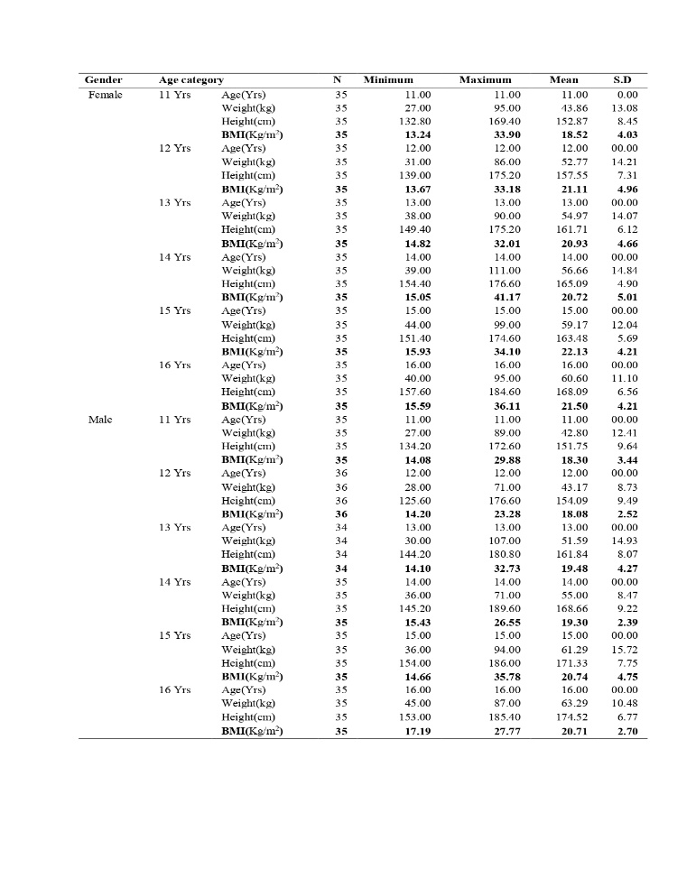SD= Standard Deviation; Yrs= years.

Table 2 shows the independent sample t test of BMI-for-age by sex. At 12 years of age, the females showed a significantly higher BMI compared to the males (p<0.05), but in other age groups studied, there was no significant sex differences in BMI

Table 2: Comparison of weight, height and BMI between genders at different age groups

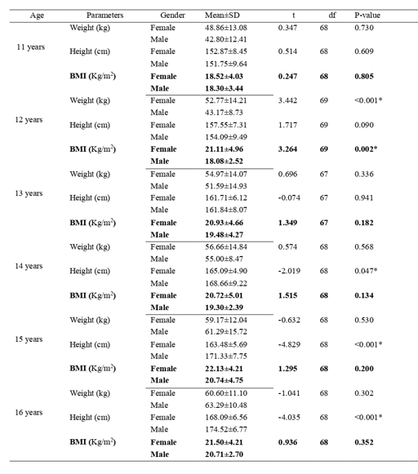

SD=Standard Deviation; df=degree of freedom; *significant.

Table 3 shows that in the sample, 72.4% (females), 73.8% (males), and 73.1% (whole sample) were within normal weight; 11.9% (females), 14.3%% (males), and 13.1% (whole sample) were within the overweight range. For obesity, females were 11.4%, males 4.8%, and the entire sample (8.1%) while underweight was 4.3% (females), 7.1% (males), and 5.7% (entire sample).

Table 3: Prevalence of underweight, normal weight, overweight and obesity by gender

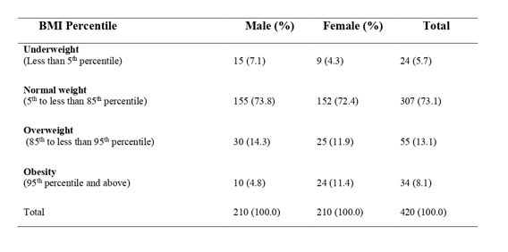

**DISCUSSION**

The weight of the subjects in both sexes increased with age. Based on the age-matched males-females, the females were initially heavier than males up to age 14years, but from age 15 to 16years, males became heavier. The observation of females being heavier than males was similar to the finding of other researchers 13,19. A similar trend between males and females occurs with regard to the mean height of subjects in which the females were initially taller than the females. This was similarly reported by Ahmad13, and Ansa20.

This trend in which females were initially taller at age 11-14 could be because females attain puberty about two years earlier than males; males gaining the two extra years thereafter to be taller.

The prevalence of overweight in the present study is comparable to the result of Okagua10. Also, the prevalence of overweight and obesity observed in the present study was higher than that reported in other studies in Nigeria 1,11,21,22. This is similarly so for the prevalence of obesity compared to the result of Okagua10. It is also higher than outcome of the study by Mahajan23 and Thomas24 among children in Mysuru, Karnataka. The discrepancy in the results could be attributed to population and demographic differences between studies.

In the present study, the prevalence of overweight is higher in males compared to females; and this could be because males are more involved in sedentary lifestyles than females. This observation is at variance with the finding of several researchers 1,7,9,10,11,22 that reported contrary. The reason for the discrepancy from the usual trend of overweight may be due to demographic factors related to the study population.

In addition, in the present study, the prevalence of obesity is higher in females compared to males. This is similar to the findings of previous studies reviewed 1,7,9,10,11,22.

This study has shown that girls had a higher BMI than boys at all ages, although this difference was not statistically significant, except at 12 years of age. This could be due to adolescent girls participating in more sedentary activities than physical activities such as sports which is similar to the findings of Ozsaker25

**CONCLUSION**

The present study has shown that in males, 7.1% is underweight, 73.8% normal weight, 14.3% overweight and 4.8% obese; while in females, 4.3% is underweight, 72.4% normal weight, 11.9% overweight and 11.4% obese.

**REFERENCES**

1. Omisore B, Akinlola O, Abioye-Kuteyi E. Original research: Obesity prevalence and metabolic differences between obese and non-obese school adolescents in south-western Nigeria, South African. Family Practice. 2015; 57(3): 172–176.
2. Ogden CL, Carroll MD, Curtin LR, McDowell MA, Tabak CJ, Flegal KM. Prevalence of overweight and obesity in the United States, 1999–2004. JAMA. 2006; 295:1549–1555.
3. Centers for Disease Control and Prevention (CDC). Division of nutrition, physical activity and obesity. 2014. <https://www.cdc.gov/nccdphp/dnpao/index.html>; Retrieved 2024-4-28.
4. CDC. Extended BMI-for-Age Growth Charts for Children and Adolescents with Severe Obesity. 2022. <https://www.cdc.gov/nccdphp/dnpao/growthcharts/extended-growth-charts.htm>; Retrieved 2024-4-30.
5. Konty KJ, Day SE, Napier MD, Irvin E, Thompson HR, D’Agostino EM. Context, importance, and process for creating a body mass index surveillance system to monitor childhood obesity within the New York City public school setting. Prev. Med. Rep. 2022; 26: 101704.
6. Patel AI, Sanchez-Vaznaugh EV, Woodward-Lopez G,.The importance of body mass index assessment and surveillance in schools. JAMA Pediatr. 2021; 175(6): 645.
7. Agu NV, Ulasi TO, Okeke KN, Ebenebe JC, Echendu ST, Nri-Ezedi CA, Nwaneli EI, Edokwe ES, Onah SK, Ifezulike CC, Umeadi ES. Prevalence of overweight and obesity among secondary school adolescents in Onitsha, Anambra State, Nigeria. International Journal of Medical Science and Clinical Invention. 2022; 9(1): 5891-5899.
8. Adeloye D, Ige-Elegbede JO, Ezejimofor M, Owolabi EO, Ezeigwe N, Omoyele C, Mpazanje RG, Dewan MT, Agogo E, Gadanya MA, Alemu W, Harhay MO, Auta A, Adebiyi AO. Estimating the prevalence of overweight and obesity in Nigeria in 2020: a systematic review and meta-analysis. Ann med. 2021; 53(1): 495–507.
9. Ujuanbi AS. Mezie-Okoye, M.M. Prevalence of overweight and obesity among adolescents in secondary school in an urban city in the Niger Delta region, Nigeria. Niger Delta Medical Journal, 2019; 3(4): 22-30.
10. Okagua J, Balafama AA, Tamunopriye J. Overweight and obesity status of school adolescents in Port Harcourt, Southern Nigeria. Niger J Med. 2016: 53-55.
11. Akinola IJ, Jarrett OO, Oduwole AO, Senbanjo IO, Njokanma OF and Rogo AD. Prevalence of overweight and obesity among secondary school adolescents in an urban area of Lagos, Nigeria. African Journal of Diabetes Medicine. 2016: 24(2): 21-23.
12. Jafari S, Fouladgar M, Naeeni MM, Fakhri M, Fatemi SA, Heidari K, Bagheri S. Body mass index, weight-for-age, and stature-for-age indicators in Iranian schoolchildren in relation to weight and growth disorders: A Population-Based Survey. Int J Prev Med. 2014; 5(2): S133-138.
13. Ahmad MM, Ahmed H, Airede K. Body mass index among school adolescents in Sokoto, North-West Nigeria. Sahel Med J. 2013; 16: 5-9.
14. Wang Y and Lobstein T. Worldwide trends in childhood obesity and overweight. International Journal of Pediatric Obesity. 2006; 1(1): 11-25.
15. World Health Organization (2021) Obesity Fact Sheet. Retrieved From who.int /health-topics/obesity Retrieved 2024-04-30
16. Orluwene CG and Nnatuanya I. Association of metabolic biomarkers of cardiovascular disease in overweight and obese children in the Emohua Local Government Area of Rivers State, Nigeria. IOSR Journal of Dental and Medical Sciences (JDMS). 2012; 1(3): 40-46.
17. Mahalakshmi S and Abirami MJ. Body mass index profile among school children: an anthropometric study. International Journal of Community Medical Public Health. 2019; 6: 3820-3824.
18. Davison KK and Birch LL. Childhood overweight: a contextual model and recommendations for future research. Official Journal of the International Association for the Study of Obesity. 2001; 2(3): 159-171.
19. Akesode FA, Ajibode HA. Prevalence of obesity among Nigerian school children in Abeokuta. Soc Sci Med. 1983; 17: 107-111
20. Ansa VO, Odigwe CO, Anah MU. Profile of body mass index and obesity in Nigerian children and adolescents. Niger J Med. 2001; 10: 78-80.
21. Toriola AL, Ajayi-Vincent OB, Oyeniyi PO, Akindutire IO, Adeagbo DI, Konwea PE, Awosusi AO, Ogunsile SE, Moselakgomo VK, Onagbiye SO and Monyeki MA Prevalence of overweight and obesity in Nigerian children. Anthropologist (2017) 30(2): 86-94
22. Lateef OJ, Njogu E, Kiplamai F, Haruna US, Lawal RA. Cake flour chlorination and alternative treatments (review). Curr Res Nutr Food Sci 2016; 4(2): 96-100.
23. Mahajan, Preetam B. Study of childhood obesity among school children aged 6 to 12 years in the union territory of Puducherry. Indian Journal of Community Medicine: Official publication of the Indian Association of Preventive & Social Medicine 2011; 36(1): 45-50.
24. Thomas UM, Narayanappa D, and Sujatha MS. Prevalence of overweight and obesity among school children in Mysuru, Karnataka. Journal of family medicine and primary care. 2021; 10(8); 2788–2792.
25. Ozsaker M. Evaluation of BMI of secondary school students in terms of some variables. Journal of Human Sciences. 2012; 9(2): 276–287.