CHANGES IN HOMA-IR AND β-CELL FUNCTION IN MALARIA INFECTED MICE TREATED WITH PHYLLANTHUS AMARUS

Uzuegbu, UE*, Opajobi, AO, Toloyai, PY, Onumaechi, IF and Onyesom, I.

Department of Medical Biochemistry, Delta State University, Abraka, Nigeria
*Corresponding Author: efiyugos@yahoo.com

ABSTRACT

Background: This study investigated changes in pancreatic beta cell function (HOMA-β), liver function markers (ALT/AST ratio), hepatic insulin resistance index (HOMA-IR) and microstructural features of pancreatic and hepatic tissues of Plasmodium berghei malarial infected mice treated with Phyllanthus amarus. This is to ascertain if the amount of insulin secreted by pancreatic β-cells has any influence on hepatic insulin resistance and glucose homeostasis.

Materials and Methods: Forty-five (45) adult Swiss albino mice with weight between 20-28g were randomly distributed into nine (9) groups (n=5/group) and used for this study. Each group was treated with grade doses (100, 200, 300mg/kg body weight) of P.amarus and chloroquine (5mg/ kg body weight) for 7days and then sacrificed. Thereafter, blood and tissue (pancreas and liver) specimens were obtained and respectively prepared for biochemical assay and histopathological examination using documented methods.

Results: Results indicate that Plasmodium berghei malarial parasite infection reduced beta cell function but increased hepatic insulin resistance with a measure of cellular damage as evidenced by the values of biomarkers (ALT: AST ratio) and microstructural alterations. However, treatment with 100mg/kg/d, 200mg/kg/d and 300mg/kg/d of P.amarus ethanol leaf extract for 7days ameliorated the P.berghei induced conditions and restored hepatic and pancreatic compromised integrity. However, chloroquine (5mg/kg/d) treatment could not protect these tissues from oxidative assault. P. amarus ethanol leaf extract offers protection to the pancreas and liver from plasmodium berghei malarial-induced damage. Therefore, the mechanism of tonic potential of P.amarus and the invigorating phytochemicals must be identified for possible therapeutic application.

Conclusion: The results obtained from this study showed that P. amarus was able to restore pancreatic beta cell function and decreased hepatic insulin resistance associated with Plasmodium berghei malarial infection in experimental mice. These observed abilities could be due to the biological activities of its active phytochemicals. P. amarus chemicals should therefore be purified for further studies.

Keywords: Phyllanthus amarus, Plasmodium berghei, Insulin, Infection, Mice, β-cell

INTRODUCTION

Malaria is a mosquito-borne infectious disease that affects both humans and animals and is caused by Plasmodium. Tropical and subtropical locations, particularly Sub-Saharan Africa, are infected with the disease. Malaria infection remains a serious worldwide health problem, with higher mortality and morbidity than any other infectious disease, despite decades of research¹. P. falciparum, one of the species that causes malaria, is responsible for the most serious complications and deaths².

According to the World Health Organization, there were 429 million documented cases of malaria in 2022, with over 608,000 people dying from the disease, many of them were children under the age of five¹. Herbal remedy has been sought in recent times due to failing chemotherapy and parasite resistance to available antimalarial drugs. Phyllantus amarus is one of such several medicinal plants undergoing crucial investigation and emerging fundamental research information has been encouraging. P. amarus has been repeatedly reported to have antimalarial activity^{16,17} and its pancreatic tonic potential²³.

The pancreas produces insulin, a peptide hormone that regulates fat metabolism and glucose homeostasis³. Glucose homeostasis is influenced by pancreatic beta cell production and insulin release, the amount of circulating insulin and its activity, tissue sensitivity to insulin, and insulin counter-regulatory hormones. During malaria infection, the intraerythrocytic malaria parasite also influences glucose homeostasis. However, in severe malaria, high levels of blood insulin have been observed to induce hypoglycemia⁷.

Hepatic or peripheral insulin resistance in
combination (whole body) or alone causes impaired glucose tolerance (hyperglycemia) which could induce pathophysiological conditions leading to certain disease development, including diabetes mellitus and syndrome X²⁵. Insulin resistance has become an area of interest in recent times due to its involvement and central role in a wide array of diseases. In this study, the impact of Phyllanthus amarus ─ a medicinal herb with antimalarial activity and pancreatic invigorating property ─ on Plasmodium berghei malarial parasite-induced changes in pancreatic beta cell function and hepatic insulin resistance was investigated in experimental mice.

MATERIALS AND METHODS
Collection and preparation of plant extract
Fresh Phyllanthus amarus plants were obtained in the wild in their natural habitat. in Abraka, Delta State, Nigeria. The plant was identified (Voucher Specimen No: FHI 109728) at the Forestry Research Institute of Nigeria Herbarium Unit (FRIN), Ibadan. Subsequently, the ethanolic leaf extract of the plant was prepared as previously documented¹⁷.

Animal care and handling
The mice received clean drinking water and were fed crop mash (Top-Feeds, Sapele, Delta State, Nigeria) ad libitum. The animals were handled according to the established standard norms (Research and Bioethics Committee, Faculty of Basic Medical Sciences, Delta State University, Abraka, Nigeria). The Laboratory Animal Center, Faculty of Basic Medical Sciences, Delta State University, Abraka, Nigeria, provided 45 Swiss albino BALB/c mice of mixed sexes weighing 20g to 28g.

They were randomly distributed randomly into nine (9) groups (with five animals per group) as follows: Group I was infected with PBS and treated with placebo-normal saline (normal control), Group 2 was infected with Plasmodium berghei (NK 65 strain, obtained from the Nigerian Institute of Medical Research (NIMR) Yaba, Lagos) and treated with the same placebo (malaria control), Also, Groups 3, 4 and 5 were parasitized (infected), but treated with 100mg/kg, 200mg/kg and 300mg/kg of Phyllanthus amarus ethanolic leaf extract respectively, Group 6 was again infected and treated with standard chloroquine dose of 5mg/kg, Groups 7, 8 and 9 were infected with PBS and treated with 100mg/kg, 200mg/kg and 300mg/kg of Phyllanthus amarus ethanolic leaf extract, respectively. The mice were inoculated using the procedure already established¹⁷. Parasitaemia was confirmed after 72hours of inoculation by documented method²³ and treatments commenced thereafter.

Animal sacrifice and collection of specimens
The mice were treated for seven (7) days via oral intubation and on the last day of such treatments they were exposed to fasting overnight and sacrificed using chloroform anesthesia the next morning, being the eighth day. The blood and tissue samples (pancreas and liver) specimens were then obtained and prepared for biochemical investigation and histological examination, respectively.

Biochemical analysis of samples
Biochemical assays were carried out to investigate changes in pancreatic β-cell function, liver insulin resistance, and liver integrity in Plasmodium berghei malarial infected mice treated with graded doses of ethanolic leaf extract of Phyllanthus amarus. Serum glucose was determined using the glucose oxidase-peroxidase (GOD-POD) enzymatic method⁸, while serum insulin was quantified using the electrochemiluminescence assay method⁹.

The Homeostasis Model Assessment (HOMA) of pancreatic β-cell function (HOMA-β) and liver insulin resistance (HOMA-IR) were calculated, respectively, using equations (1) and (2) as already published²².

HOMA-β = 360 x Insulin (µU/ml)/Glucose (mg/dL) – 63(%)…………...(1)
HOMA-IR = Glucose (mg/dL) x Insulin (µU/ml)/405……………………(2)

Liver integrity was evaluated by the ratio of biomarkers (ALT: AST). Alanine transaminase, ALT, and aspartate transaminase, AST were assayed using the spectrophotometric method¹⁰.

Commercial kits (Insulin: Meso-scale Discovery, USA: K151BZC-3, glucose: Randox, UK: GL 364, ALT: Randox, UK: AL 100 and AST: Randox, UK: AS 101) were used for the biochemical assays.

Histopathological examination: Pancreatic and liver tissues collected from sacrificed mice were immediately inserted in 10% buffered formol saline solution for at least 24hrs before the histopathological examination. The tissues were then fixed in paraffin wax and microtome sections of five micrometers (5m) were cut. These thin sections were stained with hematoxylin and eosin (H&E), then mounted on a glass slide with Canada Balsam (Sigma, USA), and examined under a binocular microscope connected to a computer for pathological abnormalities.

STATISTICAL ANALYSIS
The results of the experiments were expressed as mean SD (standard deviation). To determine the differences between groups, statistical analysis was performed using one-way analysis of variance (ANOVA) and Dunnett's post hoc test. At the 5% level (p<0.05), differences between means were judged significant.

RESULTS
The results obtained from the investigation of changes in pancreatic β-cell function, liver insulin resistance, and liver function in Plasmodium berghei malarial infected mice treated with ethanolic leaf extract of Phyllanthus amarus are presented in Table 1 and Figures 1 to 3. Alterations in the microstructures of the liver (Figures 1.1-1.9) and pancreas (Figures 2.1-2.9) are also shown.

Table 1: Changes in pancreatic β-cell function, liver integrity (ALT/AST ratio),
and liver insulin resistance, in Plasmodium berghei malarial infected mice treated with Phyllanthus amarus

Groups | Pancreatic β-cell  function (%) | Liver Function  biomarkers | Hepatic Insulin  Resistance
1 | 91.71±16.04ª | 0.76±0.10ª | 3.77±0.53ª
2 | 61.32±12.44^{b} | 1.31±0.14^{b} | 4.75±1.02^{b}
3 | 92.17±15.18ª | 0.97±0.09ª | 3.97±1.16ª
4 | 83.78±11.76ª | 0.94±0.11ª | 4.08±0.33ª
5 | 84.96±13.59ª | 0.91±0.14ª | 4.23±0.19ª
6 | 69.49±9.35ª | 1.17±0.38^{b} | 4.50±0.52^{b}
7 | 98.95±14.09ª | 0.68±0.13ª | 3.56±0.31ª
8 | 87.89±13.51ª | 0.72±0.14ª | 3.74±0.71ª
9 | 83.55±10.52ª | 0.77±0.21ª | 3.94±0.78ª

Values are expressed as Means±SD for n=5 mice per group. Values that bear different superscripts on a column differ significantly (p<0.05)
1= Normal control (uninfected and untreated mice)
2= Malaria control (infected with Plasmodium berghei and untreated)
3= Infected and treated with 100mg/kg of Phyllanthus amarus extract
4= Infected and treated with 200mg/kg of Phyllanthus amarus extract
5= Infected and treated with 300mg/kg of Phyllanthus amarus extract
6= Standard (infected and treated with 5mg/kg chloroquine)
7= Uninfected but treated with 100mg/kg of Phyllanthus amarus extract
8= Uninfected but treated with 200mg/kg of Phyllanthus amarus extract
9= Uninfected but treated with 300mg/kg of Phyllanthus amarus extract

Figure 1: Changes in Pancreatic β-cell across groups

Figure 2: Changes in AST/ALT ratio across groups

Figure 3: Changes in Hepatic insulin resistance across groups

Plasmodium berghei malaria parasite infection in experimental mice (Group 2; Table 1) significantly reduced pancreatic beta cell function with associated measure of hepatic insulin resistance and liver dysfunction compared to normal control (Group 1).
However, treatment of malarial infection with graded doses of ethanolic leaf extract of P. amarus (Groups 3, 4 and 5) restored beta cell function and significantly reduced the degree of hepatic insulin resistance and liver dysfunction. Improvements induced by P. amarus treatment were better than standard chloroquine treatment of the infection (Group 6).
Administration of P. amarus without malaria infection (Groups 7, 8 and 9) produced changes in beta cell function, liver insulin resistance, and liver function that compared well with the normal control values (Group 1). Although there were noticed concentration dependent decrease in beta cell function, increase in liver insulin resistance and liver function, these changes were not significantly different from that of normal control values and therefore, does not represent a source of worry in using the extract for treatment.

Treatment of P. berghei malaria parasite infection with varying doses of P. amarus ethanolic leaf extract in experimental mice abated malaria-induced damage to pancreatic cells. The extract had better defense of liver function and insulin resistance in the experimental mice when compared to the standard chloroquine dose (5mg/kg/d). Administration of the varying doses of P. amarus for 7days, therefore, vitalized pancreatic cells. Changes in pancreatic cell features (Fig. 2.1─2.9) give credence to the data (Table 1) observed for pancreatic β-cell function.

Figures 1.1─1.9 show the histological slides of liver tissues for the nine experimental groups as indicated.

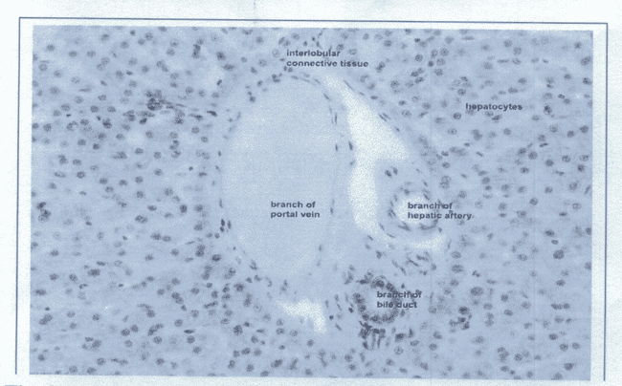

Fig. 1.1: Histology of liver tissue for normal control mice (Group 1). Features show normal structures of interlobular connective tissue, hepatocytes, branch of portal vein, branch of hepatic artery and branch of bile duct. Microscopic magnification of x100 (H & E staining)

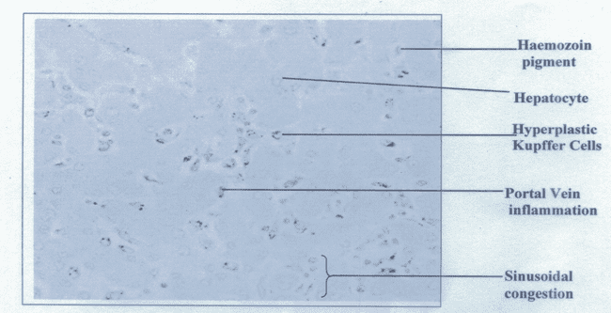

Fig. 1.2: Histology of liver tissue for the P. berghei malarial infected mice without treatment (Group 2). Microstructural features show acute damage to hepatocytes, hyperplastic Kupffer cells, portal tract inflammation, sinusoidal congestion and haemozoin pigment deposition. Microscopic magnification of x100 (H & E staining).

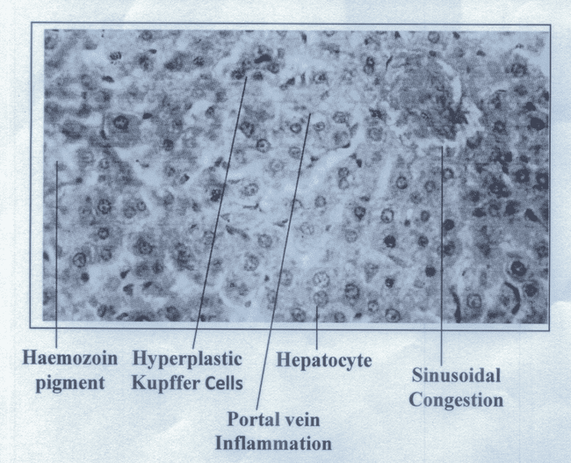

Fig. 1.3: Histology of liver tissue for mice infected with P. berghei malaria and treated with 100mg/kg of Phyllanthus amarus ethanolic leaf extract (Group 3). Features show moderate portal vein inflammation, sinusoidal congestion and presence of hyperplastic Kupffer cells. Microscopic magnification of x100 (H & E staining).

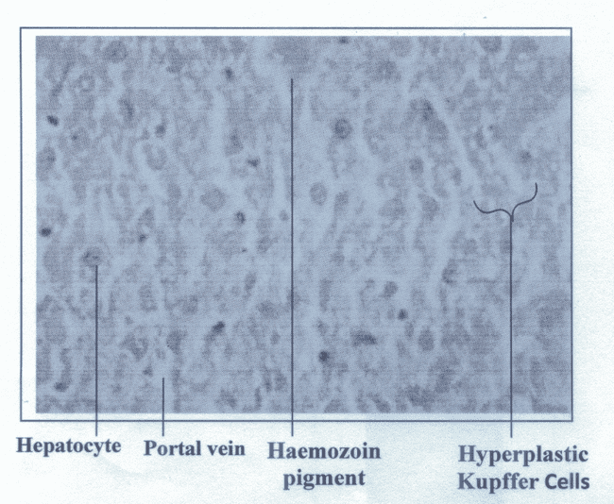

Fig. 1.4: Histology of liver tissue for mice infected with P. berghei malaria and treated with 200mg/kg of Phyllanthus amarus ethanolic leaf extract (Group 4). Features indicate mild inflammation of the portal vein, Kupffer cells and the haemozion pigment clearer. Cells are healthier compared with Group 3 (Fig. 1.3). Microscopic magnification of x100 (H & E staining).

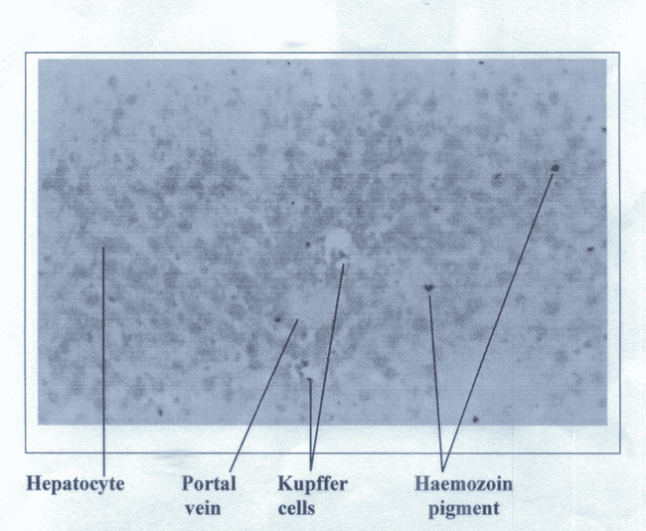

Fig. 1.5: Histology of liver tissue for mice infected with P. berghei and treated with 300mg/kg of Phyllanthus amarus leaf extract (Group 5). Features show normal portal vein and Kupffer cells. Magnification of x100 (H & E staining).

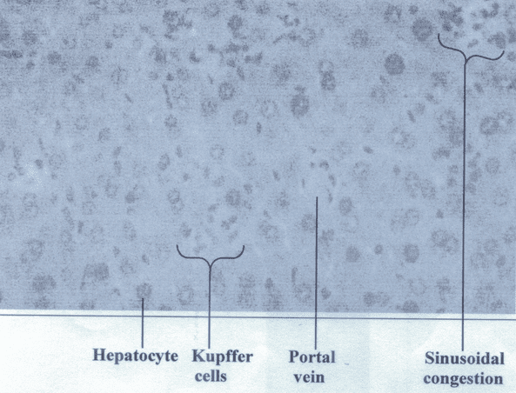

Fig. 1.6: Histology of liver tissue for mice infected with P. berghei and treated with 5mg/kg chloroquine (Group 6). Features show hepatocyte recovery. Microscopic magnification of x100 (H & E staining).

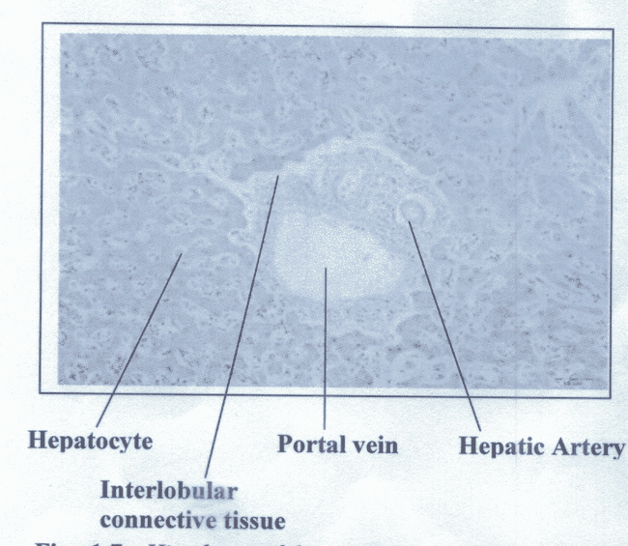

Fig. 1.7: Histology of liver tissue for uninfected mice treated with 100mg/kg of Phyllanthus amarus (Group 7). Cellular features were normal and well outlined. Microscopic magnification of x100 (H & E staining).

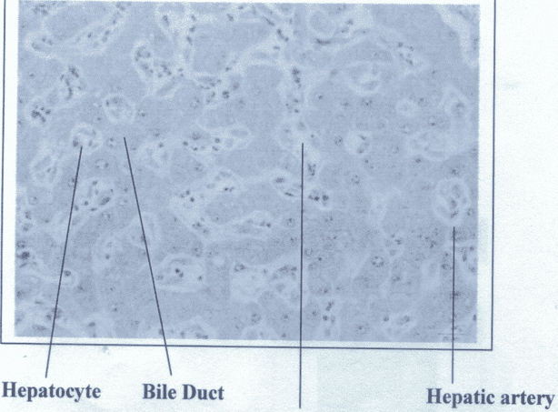

Interlobular connective tissue

Fig. 1.8: Histology of liver cells for mice without P. berghei malarial infection but administered with 200mg/kg P. amarus (Group 8). Hepatocytes, hepatic artery and interlobular connective tissue were all normal and refreshed when compared with Group 5, (Fig. 1.5). Microscopic magnification of x100 (H & E staining).

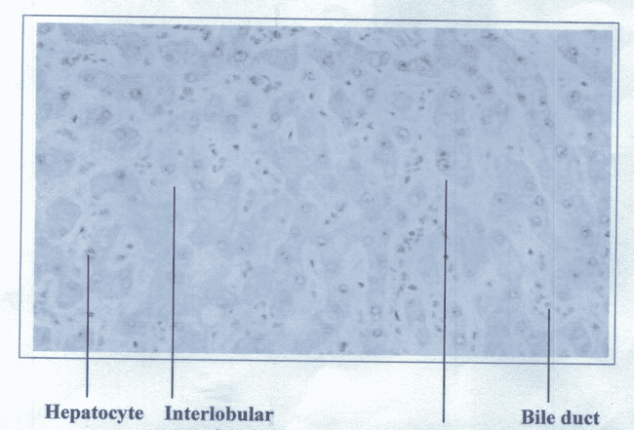

Connective tissue Hepatic artery

Fig. 1.9: Histology of liver tissue for mice without P. berghei malarial infection but treated with 300mg/kg of Phyllanthus amarus (Group 9). The Features show invigoration of the normal cells when compared with control (Group 1). Microscopic magnification of x100 (H & E staining).

Evidence from histological features (Fig. 1.1─1.9) indicates that P. berghei malarial parasite infection in experimental mice causes liver damage, but treatment with
P. amarus somewhat ameliorated such induced damage even better than standard chloroquine treatment. In addition, administration of the graded doses of P. amarus to mice without the malarial infection produced tonic activity to liver cells. These observations further support the biochemical data (Table 1).

The histopathological examination of pancreatic cells for the nine experimental groups of mice are shown in Figures 2.1─2.

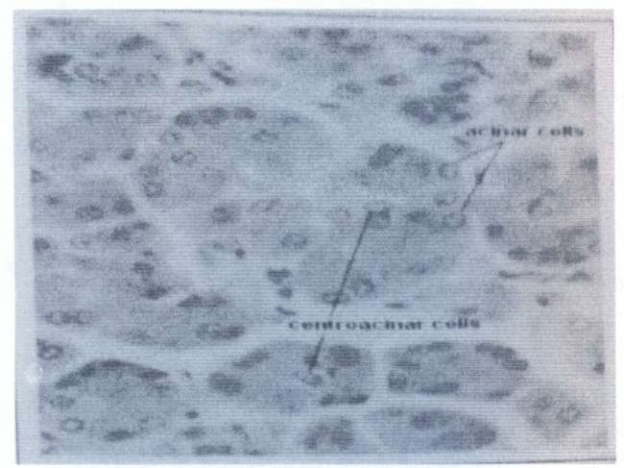

Fig. 2.1: Histology of pancreatic tissue for control mice (Group 1). Features show important sited cells which were normal. Microscopic magnification
= x100 (H & E staining).

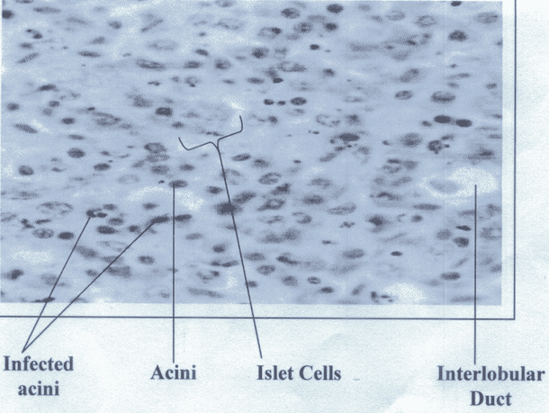

Fig. 2.2: Histology of pancreas for mice infected with P. berghei without treatment (Group 2). Pathological features show acute inflammation of the acini cells, islet cells and interlobular duct. Evidence indicates acute damage of pancreatic cells. Microscopic magnification = x100 (H & E staining).

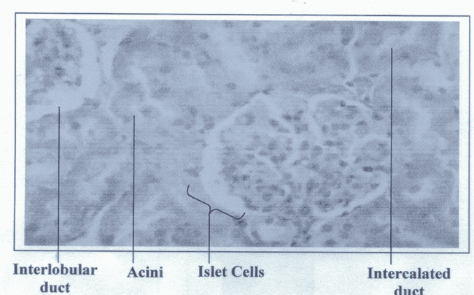

Fig. 2.3: Histology of pancreatic cells for mice infected with P. berghei and treated with 100mg/kg P. amarus (Group 3). The acini cells, islet cells and interlobular duct show very mild inflammation. Microscopic magnification= x100. (H & E staining).

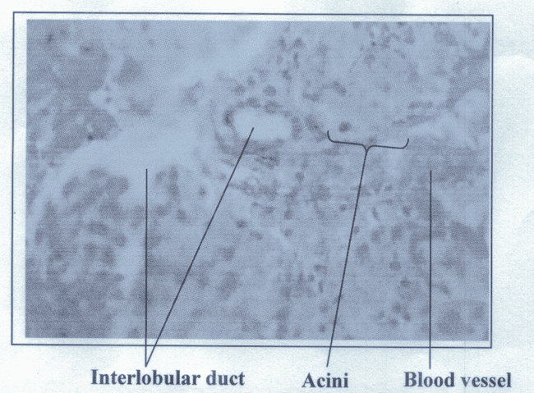

Fig. 2.4: Histology of pancreatic cells for mice infected with P. berghei and treated with 200mg/kg P. amarus (Group 4). Cells show features of recouping, though not as healthy as control. Microscopic magnification
= x100 (H & E staining).

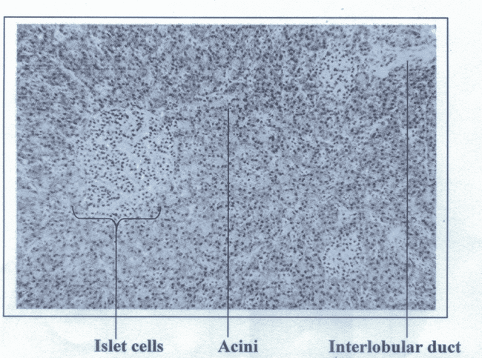

Fig. 2.5: Histology of pancreatic cells for mice infected with P. berghei and treated with 300mg/kg P. amarus (Group 5). Features show recovered cells, healthy as control. Microscopic magnification = x100 (H & E staining)

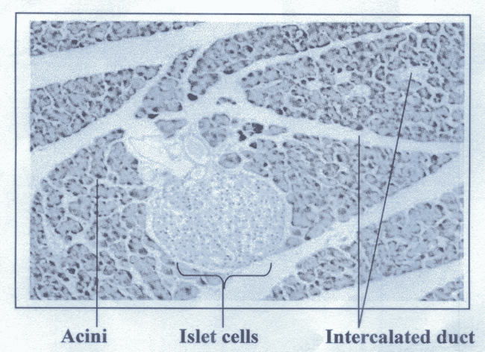

Fig. 2.6: Histology of pancreatic cells for mice infected with P. berghei and treated with 5mg/kg chloroquine (Group 6). Sited cells show mild inflammation. Microscopic magnification = x100 (H & E staining).

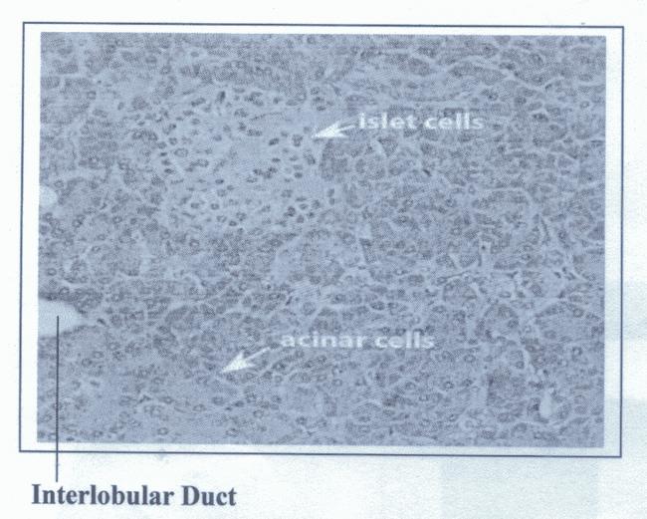

Fig. 2.7: Histology of pancreatic cells for uninfected mice administered with 100mg/kg P. amarus (Group 7). Cells appear normal. No damages. Microscopicmagnification= x100 (H & E staining).

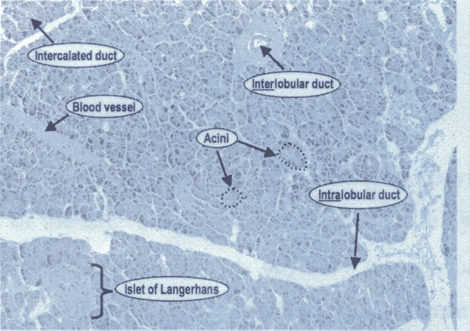

Fig. 2.8: Histology of pancreatic cells for uninfected mice administered with 200mg/kg P. amarus (Group 8). The pancreatic cells appear normal. No evidence of damage. Microscopic magnification= x100.
(H & E staining).

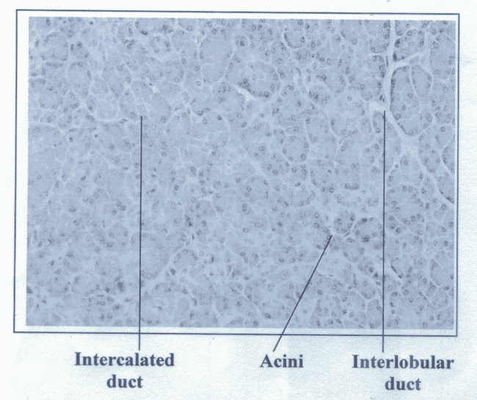

Fig. 2.9: Histology of pancreatic cells for uninfected mice administered with 300mg/kg P. amarus (Group 9). Cells were replenished compared with control (Fig. 2.1). Microscopic magnification = x100 (H & E staining).

DISCUSSION

This study demonstrates that Plasmodium berghei malarial parasite infection in experimental mice induced pancreatic cell damage (Fig. 2.2) which disturbed the pancreatic β-cell function (Table 1). This further confirms previous reports²³. Alterations in β-cell function arising from P. berghei malarial parasite induced damage to pancreatic cells causes the -cell to loose their ability to compensate for the decreased tissue insulin sensitivity, hence, the increased hepatic insulin resistance (HIR), observed during this study (Table 1). In addition, the significant increase in HIR may also be due to hepatocellular damage (Fig. 1.2) by the malarial parasite.

Malarial infection affects the liver cells (hepatocytes) since the liver is involved
in one of the stages (exo-erythrocytic) of the malaria parasite life cycle. During malarial infection, there is invasion of hepatocytes by malaria parasites and this causes liver dysfunction and alterations (increase) in activities of transaminases. The activities of alanine and aspartate transaminases (ALT and AST) are employed as indications of hepatocyte injury^{11,12,13,14}. However, this study further demonstrates that an increase in ALT/AST ratio indicates liver damage resulting from malarial infection (Table 1, Fig. 1.2).

Put together, pancreatic cell damage (decreased tissue insulin sensitivity) and hepatocellular destruction (hepatic insulin resistance) could offset glucose homeostasis and induce hyperglycaemia¹⁵. During this study, however, reduced blood glucose was observed for the P. berghei infected mice whose pancreas and liver were harmed.

The intra-erythrocytic malaria parasite influences glucose homeostasis during malarial infection. Since erythrocytes lack insulin receptors on their plasma membranes and glucose transporter I (GLUT I) facilitates glucose transfer across the membrane, they are categorized as insulin-independent tissues. When the parasite infects an erythrocyte, it changes the structure of the parasitized erythrocyte membrane by introducing parasite-derived proteins into the membrane⁴. To meet the needs of the developing intra-erythrocytic parasites, these modifications enhance the passage of nutrients into and waste products out of infected cells. The parasite's major source of energy is glucose, which is delivered to it via the P. falciparum hexose transporter (PfHT), which is not the same as GLUT I.⁵. The intra-parasitic glucose concentration may exceed that of the parasitized erythrocyte⁶. The parasite modified transportation of glucose for self-benefit, therefore, reduces plasma amounts.

Treatment of P. berghei malarial parasite infection in experimental mice with P. amarus ethanolic leaf extract at 100, 200 and 300mg/kg/d graded doses for seven days nullified the P. berghei-induced damage to the pancreas and liver more than chloroquine treatment. Both chloroquine¹⁶ and P. amarus^{17,24} have demonstrated antiplasmodial activity in experimental mice. It follows that P. amarus possessed other active chemicals that defended these organs during malarial infection.

The phytochemical contents of P. amarus include; flavonoids, saponins, tannins, glycosides, terpenoids, anthroquinone and alkaloids^{17,24}. Alkaloids have reported antimalarial properties^{18,19,20} while, flavonoids and tannins have been observed to act as primary antioxidants or free radical scavengers²¹. So, these phenolics could contribute to the protection of the liver and pancreas from oxidative damage arising from malaria parasite infection. This possibly explains why treatment with P. amarus was able to mitigate the overwhelming malarial effect on the studied organs (liver and pancreas) and improved pancreatic beta cell function and hepatic insulin sensitivity (Groups 3, 4 and 5) when compared with chloroquine treatment (Group 6), showing that chloroquine is not bestowed with any antioxidant.

CONCLUSION
The results obtained from this study showed that P. amarus was able to restore pancreatic beta cell function and decreased hepatic insulin resistance associated with Plasmodium berghei malarial infection in experimental mice. These observed abilities could be due to the biological activities of its active phytochemicals. P. amarus chemicals should therefore be purified for further studies.

ACKNOWLEDGEMENTS
The authors are grateful to Mr. Cyril Dunkwu, Department of Human Anatomy and Cell Biology, Delta State University, Abraka, Nigeria for his technical assistance.

FUNDING SOURCE
This research work had no external funding or grant, it was done by a collective contribution from all authors.

CONFLICT OF INTEREST
The authors declare no conflict of interest.

REFERENCES
- World Health Organization, WHO. World malaria report. WHO, Geneva, 2023.

- Boonpucknaviq, V. & Sitpnja, V. Renal disease in acute Plasmodium falciparum infection in man. Kidney Int. 1997; 44-48.

- DeFronzo, R.A., Bonadonna, R.C. & Ferrannini, E. Pathogenesis of NIDDM. A balanced overview. Diabetes Care. 1992; 15: 318-368

- Deitsch, K.W. & Wellems, T.E. Membrane modifications in erythrocytes parasitized by Plasmodium falciparum. Mol Biochem Parasitol. 1996; 76: 1–10.

- Krishna, S., Woodrow, C.J., Burchmore, R.J., Saliba, K.J. & Kirk, K. Hexose transport in asexual stages of Plasmodium falciparum and kinetoplastidae. Parasitol Today. 2000; 16: 516–521.

- Kirk, K., Horner, H.A. & Kirk, J. Glucose uptake in Plasmodium falciparum-infected erythrocytes is an equilibrative not an active process. Mol Biochem Parasitol. 1996; 82: 195–205.

- Al-Hussaniy H.A., Alburghaif, A.H. & Naji, M.A. Leptin hormone and its effectiveness in reproduction, metabolism, immunity, diabetes, hopes and ambitions. J Med Life. 2021; 14(5): 600-605.

- Trinder, P. Determination of glucose in blood using glucose oxidase with an alternative oxygen acceptor. Ann. Clin. Biochem.1969; 6: 24-27

- Golla, R. & Seethala, R. A sensitive, robust, high-throughput electrochemiluminescence assay for rat insulin. J. Biomol. Screeen. 2004; 9(1): 62-70

- Reitman, S. & Frankel, S.A. A calorimetric method for the determination of serum glutamic oxaloacetic and pyruvic transaminases. Amer. J. Clin. Pathol. 1957; 28(1): 56-63.

- Asagba, S.O., Owhe-Ureghe, U.B., Falodun, A. & Okoko, F. Evaluation of the toxic effect of Mansonia altisima extract after short term oral administration to rats. W. Afr. J. Pharmacol. Drug Res. 2004; 20(1/2): 53-57.

- Coppo, J.A., Mussart, N.B. & Fioranelli. S.A. Physiological variation of enzymatic activities in blood of bull frog, Ranacetesbeiana (Shaw, 1802). Rev. Vet. 2002; 12/13: 22-27.

- Dede, E.B., Igboh, N.M. & Ayalogu, O.A. Chronic toxicity study of the effect of crude petroleum (Bonny light) kerosene and gasoline on rats using hematological parameters. J. Appl. Sci. Environ. Manage. 2002; 6(1): 60-63.

- Whitehead, M. W., Hawkes N. D., Hainsworth, I. & Kingham, J. G. A prospective study of the cause of notably raised aspartate transaminase in liver origin. Gut. 1999; 45: 129-133.

- Stumvoll, M., Goldstein, B.J., and van Haeften, T.W. Type 2 diabetes: principles of pathogenesis and therapy. Lancet. 2005; 365:1333-1346

- Tolulope, O.A., Cecilia, I.I., Ibrahim, A.O. & Oluwatoyin, A.O. The antiplasmodial effect of the extracts and formulated capsules of Phyllanthus amarus on Plasmodium yoelii infection in mice. Asian Pacific J Trop Med. 2011; 283-287.

- Onyesom, I., Onumaechi, I. F., Ehiwario, J. & Dagana, R. Antiplasmodial activity of Phyllanthus amarus preserves renal function in Plasmodium berghei infected mice. Europ. J. Med. Plant. 2015; 5(1): 109-116

- Abdulelah, H.A.A. & Zainal-Abidin, B.A.H. In vivo Antimalaria tests of Nigella sativa (Black Seed) different extracts. Am J Pharmacol Toxicol. 2007; 2(2): 46–50.

- Delmas, F., Di Giorgio, C.R. & Elias. Antileishmanial activity of three saponins isolated from ivy, _- hederin, _-hederin and hederacolchiside A1, as compared to their action on mammalian cells cultured in vitro. Planta Medica. 2000; 66(4): 343–347.

- Agrawal P. Carbon- 13 NMR of flavonoids. Elsevier, Amsterdam; 1989.

- Ettebong, E., Nwafor, P., Okokon, J. In vivo antiplasmodial activities of ethanolic extract and fractions of Eluecine indica. Asian Pacif. J Trop Med. 2012; 5(9): 673-676.

- Singh, B., & Saxena, A. Surrogate markers of insulin resistance: A review. World J. Diabet. 2010; 1(2): 36-47.

- Onyesom, I. & Adu F. Phyllanthus amarus possesses malarial curative and pancreatic tonic potentials in experimental mice: Journal of Chemical and Pharmaceutical Research. 2015; 7(5): 7-15

- Oyewole, O.I., Oyedara, O.O., Olabiyi, B.F. & Fasanya, T.S. Phytochemical, antimicrobial and toxicity studies of Phyllanthus amarus whole plant extract. International Journal of Bioassays. 2013; 2(3): 519-523.

- Hernandez-Baixauli J, Quesada-Vázquez S, Mariné-Casadó R, Gil Cardoso K, Caimari A, Del Bas J. M, Escoté X, and Baselga-Escudero L. Detection of Early Disease Risk Factors Associated with Metabolic Syndrome: A New Era with the NMR Metabolomics Assessment. Nutrients. 2020; 12(3):806

