Assessment of Natural Radionuclide and Heavy Metals in Some Bread Samples in Ibadan Metropolis Oyo State, Nigeria

Ogunlesi OO¹, Ojezele OJ^{2*} and Oladejo MO³

¹Department of Physics with Electronics, Federal College of Animal Health and Production Technology, Moor Plantation, Ibadan, Nigeria
²Department of Chemistry/Biochemistry Federal College of Animal Health and Production Technology, Moor Plantation, Ibadan, Nigeria
³Department of Science Laboratory Technology, Federal College of Animal Health and Production, Moor Plantation, Ibadan, Nigeria
*Corresponding Author: omolaraojezele@gmail.com, +2348066463730

ABSTRACT

Background: Bread is regarded as one of the most predominant foods consumed among the poor. It is seen as the largest contributor to radiation doses received by the human body. Therefore, this study was carried out to evaluate the potential health implications due to natural radioactivity and heavy metals in bread samples commonly consumed in Apata, Ibadan South-West Local Government Area of Oyo State, Nigeria.

Materials and Methods: Gamma spectrometry (HpGe) was used to evaluate the potential health implications due to natural radioactivity while the heavy metals were determined using atomic absorption spectrophotometry. Relevant radiological hazard parameters and health risks assessments due to heavy metal consumption were also evaluated.

Results: Results of this study showed that the mean activity concentrations of ²²⁶Ra, ²³²Th and ⁴⁰K as 31.57$±$ 3.61, 11.46 $±$ 0.68 and 349.45 $±$ 18.25 Bqkg⁻¹ respectively. Estimation of the radiological risk parameters showed: average annual committed dose 0.04 – 0.12${mSvy}^{−1}$, absorbed dose 19.32 – 49.32${nGyh}^{−1}$, annual gonadal dose equivalent 144.59 - 255.16${µSvy}^{−1}$, radium equivalent 40.35 - 74.86${Bqkg}^{−1}$ and internal hazard index 0.10 – 0.44. These values were lower than the world average values of 1.0 ${mSvy}^{−1}$, ${59nGyh}^{−1}$, 300 ${µSvy}^{−1}$, 370 ${Bqkg}^{−1}$ and unity respectively for ingestion of natural radionuclides provided by the United Nations Committee on the effects of Atomic Radiation for any individual. Results of the heavy metal contents (mg/kg) showed: Lead BDL, Iron 25.01 – 103.89, Zinc 2.26 – 7.39, Copper 3.56 – 3.78 and Cadmium BDL. Results of health risks due to heavy metals in adult populace showed: average daily intake 0.004 – 0.647 mg/person/day, health risk index 0.040 – 7.189 and target hazard quotient 0.0006 – 0.3767. All the evaluated potential health risk parameters of the adult populace due to the heavy metal intake from consumption of the bread sample were lower than the permissible limits (apart from occurrences in THQ-target hazard quotient - values).

Conclusion: The results suggested that consumption of bread samples in the study arears may not pose significant health risk to adult populace. However, continuous consumption may pose toxicological risk due to the accumulation in the body. Hence, monitoring of the natural radionuclides and heavy metals in bread samples and other foodstuffs should be carried out for long term ingestion. This investigation may serve as a baseline study for further researches on the subject.

Keywords: Natural radioactivity, gamma spectrometry, atomic absorption spectrometry, heavy metals, radiological hazard parameters, health risk assessments

INTRODUCTION
Bread, a staple food popular around the world is regarded as one of the most consumed foodstuffs with predominant consumption among the poor¹. According to Ozbek and Akman (2016)², it is considered a fundamental component of the food pyramid. The production of bread typically employs plant materials as the active ingredient. For instance, the cereals used, which are plant-based in the soil in which they are cultivated could be contaminated by pesticides and fertilizers which may contain traces of contaminants from heavy metals³ and radioactive materials. They could also be contaminated during processing and packaging ⁴.
Natural radioactivity is widespread throughout the earth’s environment and it exists in air, water, soil, food, rocks, plants and in humans^{5, 6, 7, 8}. Radionuclides transfer through the environment by various pathways, for example, through the atmosphere, aquatic systems and soil sub-compartments; each of these pathways contribute to human exposure ⁹. A large fraction of radiation exposure occurs as a result of ingestion of foodstuffs produced in the natural environment due to the emission of gamma rays and the inhalation of radon and its daughters which can pose serious health hazards^{10,11,12}. According to International Food Safety Authorities Network ¹³, foodstuffs commonly have ²²⁶Ra, ²³²Th and ⁴⁰K and their progenies.
Heavy metals are naturally-occurring elements that have high atomic numbers and densities greater than the density of water by at least five times ^{14,15}. They are found in diversity of food materials and the environment. The occurrence of heavy metals in food often results from environmental and industrial contamination ¹⁶. They are classified as essential and non-essential heavy metals. Essential heavy metals are beneficial to human health; however, can be toxic when present at concentrations exceeding human permissible limit. Non-essential toxic heavy metals could be toxic to man even at minute concentration. Due to toxicity of heavy metals, their availability in food is of immense concern to public health due to their biotoxic effects¹⁶.
Since bread is the most popular consumed food in most countries of the world, it could be considered as one of the largest contributors of radiation doses and some metals into the human body. It is therefore important to monitor the concentrations of radionuclides and heavy metals in bread to ensure that they are within the specified safety limits. This work is aimed at evaluating the potential health implications due to natural radionuclides and heavy metal concentration via consumption of bread samples in Apata metropolis of Ibadan South-West Local Government Area of Oyo State, Nigeria.
MATERIALS AND METHODS
Sampling and preparation
Samples of the bread consumed in Apata metropolis of Ibadan South West LGA (Area 40.0km², Density: 9,943/km² population: 283,098 were collected from five bakeries (four corporate and one local). The samples were dried in an electric oven at $55℃$ for 24hours until constant weights were attained. They were grounded into fine powder and made to pass through a 2mm mesh sieve.
Natural radioactivity measurements
Measurements were carried out by adopting systems of gamma spectrometry, with a hyper pure germanium detector (HPGe), coaxial type, p-type with a relative efficiency of 20% and multichannel analyzer of about 8192 channels. The detector crystal has a diameter of about 78mm and the length of about 69.8mm with the resolution (FWHM) at 1332.5 keV and relative efficiency at 32%. The detector was shielded with a low-level background lead shield. The HPGe was calibrated for efficiency using the reference material RGU-1 from IAEA-385 for the quantitative determination of ²²⁶Ra, ²³²Th and ⁴⁰K in the bread samples. The system was set at a working energy range of 0 - 3000 keV, which accommodated the energy range of interest in the study. The specific activity of ⁴⁰K was directly identified from the peak areas at 1460 keV. The activity concentrations of ²³⁸U and ²³²Th were measured presuming secular equilibrium with their decay products. To measure the activity concentration of radioisotope in the ²³⁸U-series, gamma transition lines of ²¹⁴Bi (1765 keV) were employed. Also, radioisotope activity concentrations in the ²³²Th-series were identified by applying gamma transition lines of ²⁰⁸Tl (2614 keV). The average counting time is 10,800 s for each sample in the set geometry, to ensure a good statistical significance.
The activity concentration of the samples in BqKg⁻¹ was evaluated by the expression given by Ebaid, (2010)¹⁷:
A_{sp} (E,i) = $\frac{N_{sam}\left(E,i\right)}{εγ\left(E\right).T_{c}.P_{γ}\left(E,i\right).M_{sam}}$ (1)
Where N_{sam} (E,_{i}) is the net counts for the radionuclide i at energy E, ε_{γ}(E) is the photo peak efficiency at energy E, T_{c} is the counting live-time (secs), Pγ(E, i) is the gamma emission probability of the radionuclide i for a transition at energy E, M_{sam} is the dry-weight of samples in kg.
The annual effective dose rate, E (${mSvy}^{−1}$) received by the population was calculated using the equation given by UNSCEAR (2008)¹⁸;
E (${mSvy}^{−1}$) = D (nGy/hr) x 8760 h x 0.4 x 0.7 Sv/Gy x 10⁻⁶ (2)
Where E = annual effective dose rate, D = absorbed dose rate and h is hours, a dose conversion factor of 0.7Sv/Gy and outdoor occupancy factor of 0.4 (considering that he people in in this area spend 40% (about 10 hours) of their time outdoor on average.
The absorbed dose rate in air 1m above the ground surface for the radionuclides (²²⁶Ra, ²³²Th and ⁴⁰K) was computed on the basis of guidelines provided by UNSCEAR (2000)¹⁸. It was evaluated using the expression given by UNSCEAR (2008)¹⁹:
D (${nGyh}^{−1}$) = ${0.429A}_{Ra}$ + ${0.606A}_{Th}$ + ${0.0417A}_{K}$ (3)
Where, A_{Ra}, A_{Th} and A_{K} are activity concentrations of ²²⁶Ra, ²³²Th and ⁴⁰K respectively.
The annual gonadal dose equivalent (AGDE) is a measure of the genetic significance of the yearly dose received by the population’s reproductive organs²⁰. The gonads, the bone marrow and the bone surface cells are considered as organs of interest by UNSCEAR (2000)¹⁸ because of their sensitivity to radiation. The annual gonadal equivalent dose equivalent due to specific activities of ²²⁶Ra, ²³²Th and ⁴⁰K was estimated using the expression^{21,22}:
AGDE (μSvy⁻¹) = 3.09 A_{Ra} + 4.18 A_{Th} + 0.314 A_{K} (4)
Where, A_{Ra}, A_{Th}, and A_{K} are the radioactivity concentration of ²²⁶Ra, ²³²Th and ⁴⁰K in the samples.
Radium equivalent activity represents a weighted sum of activities of ²²⁶Ra, ²³²Th and ⁴⁰K and is based on the estimation that 1Bq kg⁻¹ of ²²⁶Ra, 0.7Bq kg⁻¹ of ²³²Th and 13Bq kg⁻¹ of ⁴⁰K produce the same radiation dose rates²³. The index is given by an expression by UNSCEAR (2000)¹⁸:
Ra_{eq} (Bqkg⁻¹) = A_{Ra} + 1.43 A_{Th} + 0.077 A_{K} (5)
Where, A_{Ra}, A_{Th} and A_{K} are activity concentrations of ²²⁶Ra, ²³²Th and ⁴⁰K respectively.
Taking into consideration the hazardous effects of radon a progeny of radium and its short-lived products to the respiratory organs, the internal exposure is quantified by the internal hazard index (H_{in}) using the expression given by Tufail et al., (2000)²⁴:
H_{in} = $\frac{A_{Ra}}{185}$ + $\frac{A_{Th}}{259}$ + $\frac{A_{K}}{4810}$ (6)
Where, A_{Ra}, A_{Th}, and A_{K} are the radioactivity concentration of ²²⁶Ra, ²³²Th and ⁴⁰K in the samples. The internal hazard index has to be less than unity as well to provide safe radionuclide levels in medicinal plants²⁵.

Heavy metal analysis
0.5g was weighed from each sample, digested in a mixture of nitric acid (${HNO}_{3}$, sulphuric acid (${H_{2}SO}_{4}$ and perchloric acid (${HClO}_{4}$(10:2:1, by volume) and made up to mark (25 ml) with distilled water for heavy metal analysis²⁶. The heavy metals analyzed were Cu, Zn, Fe, Pb and Cd. These metals of interest were analyzed using PerkinElmer atomic absorption spectrometry (Analyst 300 AAS). All determinations were done in duplicates and values reported in mg/kg.
The potential health risks of the populace due to heavy metals intake from the consumption of bread samples from study areas were evaluated using some parameters such as estimated daily intake, health risk index, and target hazard quotients. Health risk assessment has been generally used in research associated with human healthiness²⁷.
Estimated daily intake (EDI) of heavy metals depends on the metal concentration in food, average daily intake, and the body weight. It was calculated based on the expression given by Orisakwe et al (2012)²⁸:
EDI = $\frac{C_{m}xD_{fi}}{B_{avg}}$ (7)
Where, EDI = estimated daily intake, C_{m} = heavy metal concentration in foodstuff (mg/kg), D_{fi} = daily intake of vegetable (kg/person) and B_{avg} = average body weight.
The average body weights for adults were considered to be 55.9kg²⁹, while average daily intakes for adults were considered to be 0.09kg/person/day³⁰.
Health risk index refers to the ratio of the daily intake of metals in food materials to the oral reference dose³⁰. This was evaluated using the expression given by Okereke et al (2016)³¹:
HRI = $\frac{EDI}{R_{f}D}$ (8)
Where HRI = health risk index, EDI = estimated daily intake of metal and $R_{f}D$ = oral reference dose (Pb, Cd, Cu, Zn and Fe values were 0.0035, 0.001, 0.040, 0.300 and 0.09 mg/kg/day respectively)³².
An HRI > 1 for any metal in food crops means that the consumer population faces a health risk³¹.
To estimate the level of concern originating from ingestion of metals through the consumption of these brands of biscuit, the target hazard quotient (THQ) values were calculated by using the determined concentrations of seven metals. It is essential to assess the non-carcinogenic risk in order to determine the potential health effects of contaminants via regular consumption of several metal ions^{33,34}. Target hazard quotient is among the methods applied in examining lifetime exposure to metals through diets³³. Target hazard quotient is a ratio between the measured heavy metal concentration and the oral reference dose weighted by the length and frequency of exposure; amount ingested and body weight³⁵. The THQ values via the ingestion of bread by adults were determined based on the expression given by Adedokun et al, (2016)³⁶:
THQ = $\frac{{EF}_{r}xEDxFIRxC_{m}}{R_{f}DxB_{avg}x{AT}_{n}}$ $×$ ${10}^{−3}$ (9)
Where THQ = target hazard quotient, ${EF}_{r}$ = the exposure frequency (350 days/year), ED = the exposure duration (54years, equivalent to the average lifetime of the Nigeria population), FIR = food ingestion rate (bread consumption values for adult Nigerian is 0.18kg/person/day) (36), $C_{m}$ = metal concentration in the bread samples (mgkg⁻¹), $R_{f}D$ is the oral reference dose,$B_{avg}$ = the average body weight (55.9kg for adults food consumer in South-Western Nigeria)³¹; and ${AT}_{n}$ = average exposure time for non-carcinogens (ED x 365 days/year).
If THQ value is greater than 1, the exposure is likely to cause obvious adverse effects³⁶.

RESULTS AND DISCUSSION
Activity concentration in the bread samples
The activity concentration due to ²²⁶Ra, ²³²Th and ⁴⁰K in five bread samples commonly consumed in Apata area of Ibadan South-West LGA of Oyo State, Nigeria have been determined and the results are presented in Table 1. Activity concentrations of radionuclides less than the corresponding detectable levels of 0.0975 Bq/kg, 0.0255 Bq/kg and 0.00787 Bq/kg for ⁴⁰K, ²²⁶Ra and ²³²Th respectively are termed as below detectable level (BDL) for each radionuclide. The specific activity concentration of ²²⁶Ra ranged from BDL (Sample B) to 55.17 ± 6.36 ${Bqkg}^{−1}$ (Sample C) with a mean value of 31.57$±$ 3.61 ${Bqkg}^{−1}$. For the activity concentration of ²³²Th, it varied from 3.59 ± 0.21 (Sample A) to ${14.93±0.89Bqkg}^{−1}$ (Sample C) with a mean value of 11.46 $±$ 0.68${Bqkg}^{−1}$.The activity concentration of ⁴⁰K ranged between 298.58 ± 15.14 (Sample A) to 413.57 ± 21.74 ${Bqkg}^{−1}$ (Sample D) with a mean value of 349.45 $±$ 18.25 Bqkg⁻¹. Comparison of the activity concentrations of radium, thorium and potassium in the bread samples are given in Figure 1. The figure compared values obtained from this study with acceptable limit of 35${Bqkg}^{−1}$, 30 ${Bqkg}^{−1}$ and 400 ${Bqkg}^{−1}$ respectively set by UNSCEAR¹⁸. ⁴⁰K recorded the highest activity concentrations in all the bread samples compared to that of ²²⁶Ra and ²³²Th. ⁴⁰K, an isotope of potassium, is an important nutrient of plants in their metabolic activities and is available in abundance in the soil when compared with other radionuclide.

Radiological hazard risk assessment
The results of the radiological hazard risk parameters are presented in Table 2. The annual committed effective doses (E) due to the ingestion of ²²⁶Ra, ²³²Th and ⁴⁰K in the bread samples varied from 0.04 (Sample B) to 0.12 ${mSvy}^{−1}$ (Sample C) with a mean value of 0.08 ${mSvy}^{−1}$. These values are below the acceptable value of effective dose of 1.0 ${mSvy}^{−1}$ for the public¹⁸.
The gamma absorbed dose rate (D) in air ranged between 19.32 ${nGyh}^{−1}$in Sample B and 49.32 ${nGyh}^{−1}$ in Sample C with a mean value of 34.96${nGyh}^{−1}$. These results are below the estimated average global terrestrial radiation of ${59nGyh}^{−1}$ reported by UNSCEAR ¹⁸
The annual gonadal dose equivalent (AGDE) of the study varied between 144.59 ${µSvy}^{−1}$in (Sample B) to 357.88 ${µSvy}^{−1}$in (Sample C) with a mean value of 255.16${µSvy}^{−1}$. The mean value of the study is within the permissible limit of ${300µSvy}^{−1}$ ¹⁸
The radium equivalent activity (${Ra}_{eq}$) ranged from to 40.35 ${Bqkg}^{−1}$ to 107.17 ${Bqkg}^{−1}$ with a mean value of 74.86${Bqkg}^{−1};$these values are considered to be safe since they are well below the limit of ${370Bqkg}^{−1}$ recommended by UNSCEAR¹⁹.
The estimated internal hazard indices of the study ranged from 0.10 to 0.44 with a mean value of 0.29. These values less than unity confirm its safety with respect to ingestion of the bread samples.
Comparing all the values of the evaluated hazard risk parameters in the bread samples, it was observed that Sample B had the least value while Sample C had the highest.
Comparison of Activity Concentrations with Previous Studies
Table 3 shows the comparison between the activity concentrations of ²²⁶Ra, ²³²Th and ⁴⁰K for the present study with the similar previously published work. The obtained values for ²³²Th and ⁴⁰K were lower than reported values from other studies whereas the activity concentration of ²²⁶Ra was higher than values of the reported data in the literature. These variations could be due to the differences in geographical location and radiochemical composition of the soils of the countries in which plant materials for making bread were cultivated. Also, food preservatives or additives may also contribute to increase the concentrations of natural radionuclides in bread.

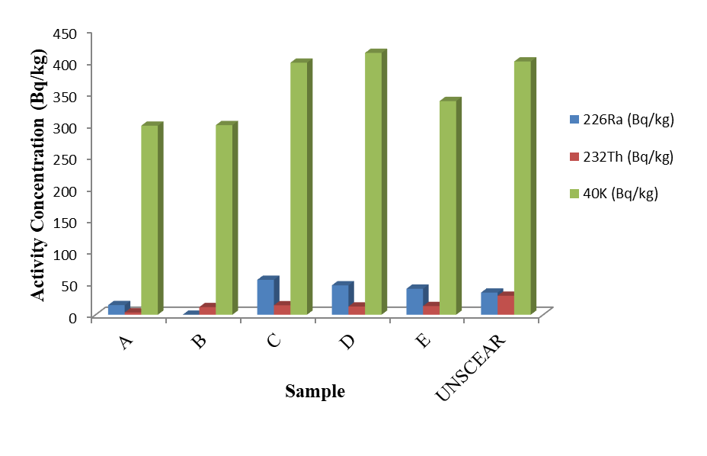
Figure 1: Comparison of the activity concentration of ²²⁶Ra, ²³²Th and ⁴⁰K (${Bqkg}^{−1}$) in the bread samples with the acceptable values by UNSCEAR¹⁸

Heavy metal concentration in the bread samples
Results of the heavy metal concentration of the commonly consumed bread samples within Apata metropolis are presented in Figure 2. In the study, the concentration of Zn, Fe, Cu, Cd and Pb were determined by atomic absorption spectrometry.
Among all the essential heavy metals, Zinc is the least toxic and one of the important micronutrients required as a co-factor by more than 200 enzymes that play a vital role in the physiological and metabolic process of many organisms³⁷. Zn content ranged between 2.26 ± 0.09 and 7.39 ± 0.13 ${mgkg}^{−1}$; the highest value observed in Sample C while Sample A gave the least. The Zn content in the bread samples were far below the $99.4{mgkg}^{−1}$ permissible level set by³⁸.
Copper is an essential micronutrient necessary for the growth and formation of myelin sheaths in the nervous systems, helps in the incorporation of iron in haemoglobin, assists in the absorption of iron from the gastrointestinal tract (GIT) and in the transfer of iron from tissues to the plasma³⁹. It varied from 3.56 ± 0.08 and 6.17 ± 0.03 ${mgkg}^{−1}$ with the lowest value recorded in Sample A and the highest content in Sample C. The values obtained are lower than the permissible limit of 73.3${mgkg}^{−1}$ set by³⁸.
Iron functions as haemoglobin in the transport of oxygen⁴⁰. It facilitates the oxidation of carbohydrates, protein and fat to control body weight, which is very important in diabetes. The values ranged from 25.01 ± 1.51 (Sample E) to 103.89 ± 1.00${mgkg}^{−1}$ (Sample C). Values obtained are below the recommended limit of 4$26{mgkg}^{−1}$ in food by³⁸. Low iron content causes gastrointestinal infection, nose bleeding and myocardial infection⁴¹.
The presence of non-essential heavy metals, such as Cd and Pb is an indication that the environment is not free from pollution. Lead is a physiologic and neurological toxin that can affect several organs and organ system in the human body⁴². The concentration of Pb was not detected in the bread samples of the study. The maximum permissible limit set by (38) is 0.3${mgkg}^{−1}$.
Cadmium is a highly toxic element in foods and natural waters and it accumulates principally in the kidneys and liver⁴³. It does not have a role in biological process in living organisms. Thus, even in low concentration, Cd could be harmful to living organisms⁴⁴. Cadmium was not detected in in the bread samples of the study. The permissible limit is 0.2${mgkg}^{−1}$.

Health risk assessment due to exposure of heavy metals in the bread samples
The potential health risks of the populace due to heavy metals intake from the bread samples were evaluated and the results are presented in Figures (3), (4) and (5). The estimated daily intake (mgperson⁻¹day ⁻¹) (Figure 3) values showed that Fe ranged from 0.040 (Sample E) to 0.647 (Sample D); Zn ranged between 0.004 (Sample A) and 0.012 (Sample C) and Cu ranged between 0.006 and 0.010. Comparing the results with the permissible limits, all the metals were lower that required intake and this could suggest that consumption in the bread samples of the study may not pose any significant health risk to the adult populace.
Figure 4 shows the health risk index (HRI) of heavy metals for adults via consumption of the bread samples of the study. The HRI ranged as follows; Fe (0.444 – 7.189), Zn (0.040 - 0.133) and Cu (0.150 - 0.250). The HRI for the metals from this study were lower than unity except for Fe in Samples C and D. Generally, HRI < 1 means that the exposed population is safe of metals health risk⁴⁵.
The estimated target hazard quotients of selected heavy metals through the consumption of bread samples for adults’ population of the study area are presented in Figure 5. The THQ values of Zn, Cu, Fe, Cd and Pb ranged as follows: Fe (0.0232 – 0.3767), Zn (0.0006 – 0.0021) and Cu (0.0074 – 0.0129). No values were obtained for both Cd and Pb. The individual THQ values for metals for all samples follow the order: Fe > Cu > Zn > Cd = Pb. Generally, Cu and Zn, which are important nutrients for humans, are considered a much lower health risk to humans than Mn, and Fe⁴⁶. In this study, the THQ in all the heavy metals is far less than 1 in all the bread samples; therefore, it may not pose health risk concern.

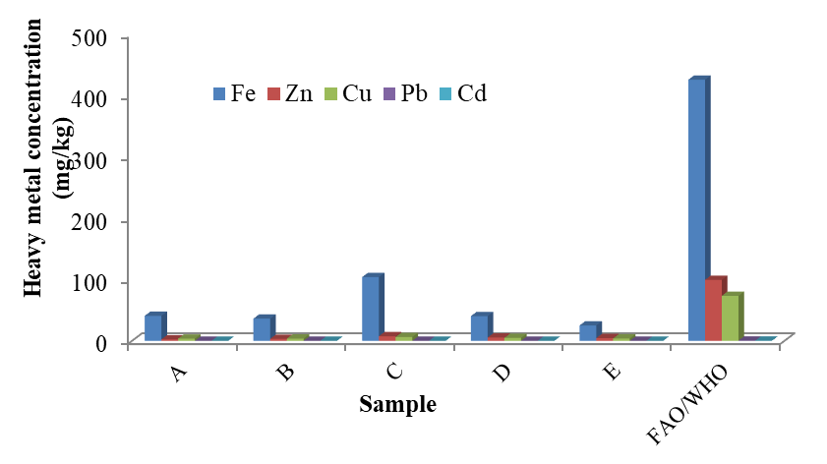
Figure 2: Heavy metal profile of the bread samples (mg/kg) of the study compared with FAO/WHO³⁸ safe limits.
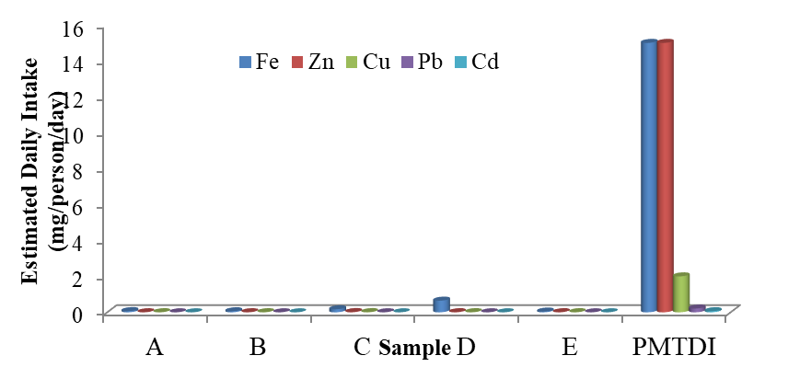
Figure 3: Estimated average daily intake due to heavy metals in adults compared with
Permitted maximum tolerable daily intakes (PMTDI) endorsed by WHO/FAO

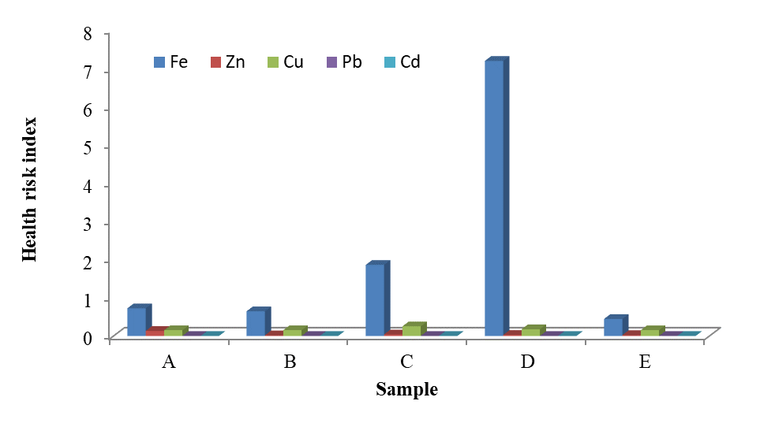
Figure 4: Health risk index due to heavy metals in adults’ populace via consumption of bread samples commonly consumed in Apata metropolis.

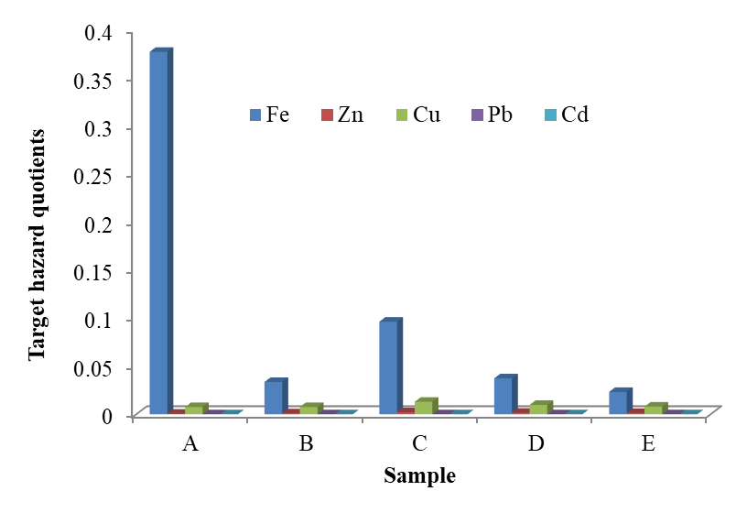
Figure 5: Target hazard quotient due to heavy metals in adults’ populace via consumption of bread samples commonly consumed in Apata metropolis.

4.0 Conclusion
This study assessed the potential health implications due to natural radionuclides and heavy metals in commonly consumed bread in Apata metropolis, Ibadan South-West Local Government Area of Oyo State, Nigeria using gamma-ray spectrometry and atomic absorption spectrometry respectively. The average activity concentrations of ²²⁶Ra, ²³²Th and ⁴⁰K were lower than the allowed limits for all samples. The radium equivalent activities and the internal hazard indices were calculated to assess the radiological hazards from the consumption of the bread samples. All of the calculated values were lower than the recommended level. Thus, the accumulation of radionuclides in wheat flour and bread samples under investigation did not pose any health risks. Heavy metals were found in the bread samples at varying concentrations. The concentration of heavy metals such as iron, copper, zinc, lead and cadmium were below the WHO permissible limits. Most of the evaluated potential health risk parameters of the adult populace due to the heavy metal intake from consumption of the bread sample lower the permissible limits could suggest that consumption of the bread samples of the study may not pose any significant health risk to adult populace. However, regular monitoring of the natural radionuclides and heavy metals in bread samples and other foodstuffs should be carried out for long term ingestion.

REFERENCES
- Maziya-Dixon B, Akinyele IO, Oguntona EB, Nokoe S, Sanusi RA, and Hamis E. Nigeria food consumption and nutritional survey 2001-2003..2004; IITA, Ibadan, p. 67.
- Ozbek N, Akman S. Method development for the determination of calcium, copper, magnesium, manganese, iron, potassium and zinc in different types of breads by microwave induced plasma-atomic emission spectrometry, Food Chem. 2016; 200: 245-248.
- Ubuoh EA. Analysis of metal concentrations in selected canned beers consumed in Owerri Urban, Imo State, Nigeria. Int. J. Chem. Mat. Sci. 2013; 1: 90 – 95.
- Magomya AM, Yebpella GG, Udiba UU, Amos HS, Latayo MS. Potassium bromate and heavy metal content of selected bread samples produced in Zaria, Nigeria. Int. J. Sci. & Techn. 2013; 2(2): 232-237.
- Tettey-Larbi L, Darko EO, Schandor FC, Appiah AA. Natural Radioactivity Levels of Some Medical Plants Commonly used in Ghana. Springer Plus. 2013;. 2: 157-185
- Yang YX, Wu XM, Jiang ZY, Wang WX, Lu JG. Radioactivity concentration in soil of the Xiazhuang granite area, China. Applied Radiation and Isotopes. 2005; 63: 255-259.
- Al-Hamidawi AAA, NORM in instant noodles (Indomie) sold in Iraq. Environmental Analytical Chemistry. 2015; 2: 1-4.
- Ahmad N, Jaafar MS, Bakhash M, Rahim M. An overview on measurements of natural radioactivity in Malaysia. Journal of Radiation Research and Applied Sciences. 2015; 8: 136 - 141.
- Alshahri F. Evaluation of radionuclides contamination in wheat flour and bread using gamma-ray spectrometry. Life Science Journal. 2016; 13 (3): 34 – 42.
- Hosseini T, Fathivand AA, Barati H, Karimi M. Assessment of radionuclides in imported foodstuffs in Iran. Iranian Journal of Radiation Research. 2006; 4: 149-153.
- Asaduzzaman KH, Khandaker MU, Amin YM, Bradley D A, Mahat RH, Nor RM. Soil-to-root vegetable transfer factors for ²²⁶Ra, ²³²Th, ⁴⁰K, and ⁸⁸Y in Malaysia. Journal of Environmental Radioactivity. 2014; 135: 120 - 127.
- Kant K, Gupta R, Kumari R, Gupta N, Garg M. Natural radioactivity in Indian vegetation samples. International Journal of Radiation Research. 2015; 13: 143-150.
- INFOSAN (International Food Safety Authorities Network). International Food Safety Authorities Network. (2011). Information on Nuclear Radioactive Contamination of foods, Geneva, Switzerland.
- Tchounwou PB, Yedjou CG, Patlolla AK, Sutton DJ. Heavy Metals Toxicity and the Environment. Natl. Inst. Health. 2012; 101: 133–164.
- Izah SC, Chakrabarty N, Srivastav AL. A Review on Heavy Metal Concentration in Portable Water Sources in Nigeria: Human Health Effects and Mitigating Measures. Exp. Health. 2016; 8: 285 – 304.
- Izah SC, Inyang IR, Angaye TCN, Okowa IP. A review of heavy metal concentration and potential health implications of beverages consumed in Nigeria. Toxics. 2017; 5 (1): 1 – 15.
- Ebaid YY. Use of Gamma Ray Spectrometry for Uranium Isotopic Analysis of Environmental Samples. Romanian Journal of Physics. 2010; 55(1–2): 69 – 74.
- UNSCEAR. United Nations Scientific Committee on the Effects of Atomic Radiation, Sources and Effects of Ionizing Radiation Reports to the General Assembly. (2000). United Nation, New York.
- UNSCEAR. Sources and Effects of Ionizing Radiation. Report of the United Nations Scientific Committee on the Effects of Atomic Radiation to the General Assembly, with Scientific Annexes, (2008). United Nations, New York.
- Ravisankar R, Sivakumar S, Chandrasekaran A, Prakash J, Vijayalakshmi I, Vijayagopal P. Spatial Distribution of Gamma Radioactivity Levels and Radiological Hazard Indices in the East Coast Sediment of Tamilnadu, India with Statistical Approach. Radiation Physics Chemistry, 2014; 103, 89 - 98.
- Isinkaye MO, Agbi JI. Natural radioactivity and associated radiation hazards of some commonly used building materials in southwest Nigeria. Radioprotection. 2013; 48: 355 – 365
- Avwiri GO, Egieya JF, Chinyere PO. Radiometric Survey of Aluu Landfill in Rivers State, Nigeria. Adv. Phys. Theor. Appl. 2013; 22: 24 – 30.
- Tufail M, Iqbal M, Mira S. Radiation Doses Due to the Natural Radioactivity in Pakistan Marble. Radioprotection. 2000; 35: 299-310.
- Diab HM, Nouh SA, Hamdy A, El-Fiki SA. Evaluation of Natural Radioactivity in a Cultivated Area around a Fertilizer Factory. Journal of Nuclear Radiation Physics 2008; 3(1): 53 - 62.
- Zafar N, Khan MA, Ahmad N, Rehman Z. Element Analysis of Some Medicinal Plants used in Traditional Medicine by Atomic Absorption Spectrometer. Journal of Medicinal Plants Research. 2010; l 4(19): 1987 - 1990.
- Aigberua AO, Izah SC, Isaac UI. Level and health risk assessment of heavy metals in selected seasonings and culinary condiments used in Nigeria. Biol Evid. 2018; 8: 6 - 20.
- Orisakwe OE, Nduka JK, Amadi CN, Dike DO, Bede O. Heavy metal health risk assessment for population via consumption of food crops and fruits in Owerri, South Eastern Nigeria. Chem Cent J. 2012; 6 (1): 77.
- Wang X, Sato T, Xing B, Tao S. Health risks of heavy metals to the general public in Tianjin, China via consumption of vegetables and fish. Science and Total Environment, 2005; 350: 28–37.
- USEPA. A review of the reference Dose and Reference concentration Processes. United States Environmental Protection Agency, USA.28. CDCP (2015). Fruits and vegetables: Nutrition for everyone - Centres for Disease Control and Prevention. USA.
- Okereke CJ, Essien EB. and Wegwu MO. Human Health Risk Assessment of Heavy Metal Contamination for Population via Consumption of Selected Vegetables and Tubers Grown in Farmlands in Rivers State, South-South Nigeria. J Anal Pharm Res. 2016; 3(6): 00077.
- US-EPA IRIS. United States, Environmental Protection Agency, Integrated Risk Information System. (2006). http://www.epa. gov/iris/subst., accessed October 2020.
- Iwegbue CM, Nwozo SO, Overah CL, Bassey FI, Nwajei GE. Concentrations of selected metals in some ready-to-eat-foods consumed in southern Nigeria: estimation of Dietary intakes and target hazard quotients. Turk J Agri Food Sci Technol. 2013;. 1: 1-7.
- Ullah H, Noreen S, Rehman A, Waseem A, Zubair S. Comparative study of heavy metals content in cosmetic products of different countries marketed in KhyberPakhtunkhwa, Pakistan. Arab J Chem. 2017; 10: 10-18.
- Tsafe, A. I., Hassan, L. G., Sahabi, D. M., Alhassan, Y. and Bala, B. M. Evaluation of Heavy Metals Uptake and Risk Assessment of Vegetables Grown in Yargalma of Northern Nigeria. Journal of Basic and Applied Science Research. 2012; 2(7): 6708-6714.
- Adedokun, A. H., Njoku, K. L., Akinola, M. O., Adesuyi, A. A. J., Anuolwapo, O. Potential Human Health Risk Assessment of Heavy Metals Intake via Consumption ofsome Leafy Vegetables obtained from Four Market in Lagos Metropolis, Nigeria. 2016; pp. 14
- Nwanguma BC, Okorie CH. Salt (sodium chloride) content of retail samples of Nigerian white bread: implications for the daily salt intake of normotensive and hypertensive adults, Journal of Human Nutrition and Dietetics. 2013; 26(5): 88-492.
- Grodner M, Anderson S, Deyoung S. Foundation and Clinical Applications of Nutrition, 2nd Ed., Mosby Inc., St. Louis, Missouri, 2000; 45-107.
- FAO/WHO, Codex Alimentarius Commission. Food additives and contaminants. Joint FAO/WHO Food Standards Programme, & World Health Organization. Codex Alimentarius: General requirements (food hygiene). ALINORM. (2001). 01/12A: 1-289.
- Murray RK, Granner DK, Mayes PA, Rodwell VW. Harper’s Biochemistry 25th Edition, McGraw-Hill, Health Profession Division, USA, (2000). pp. 104 – 110.
- Soetan KO, Olaiya CO, Oyewole OE. The Importance of Mineral Elements for Humans, Domestic Animals and Plants: A Review, African Journal of Food Science. 2010; 4: 200 - 222.
- Moscow S, Jothivenkatachalam K. Study on Mineral Content of Some Ayurvedic Indian Medicinal Plants, International Journal of Pharma Sciences and Research. 2013; (2): 0975 – 9492.
- Diallo M, Traore A, Gueye, PEO, Wague A, Lutgen P, Sarr O, Mboup S. Characterization of Element and Mineral Content in Artemisia annua and Camelia sinensis Leaves by Handheld X-ray Fluorescence. African Journal of Biotechnology. 2013; 12 (26): 4179 – 4186.
- Divrikli U, Horzum N, Soylak M, Elci L. Trace Heavy Metal Contents of Some Spices and Herbal Plants from Western Anatolia, Turkey. International Journal of Food Science & Technology. 2006; 41 (6): 712 - 716.
- Ambedkar G, Muniyan M. Analysis of heavy metals in water, sediments and selected fresh water fish collected from Gadilam river, Tamilnadu,India. International Journal of Toxicology and Applied Pharmacology. 2012; 2 (25).
- Khan S, Lin A, Zhang S, Huc Q, Zhu Y. Accumulation of polycyclic aromatic hydrocarbons and heavy metals in lettuce grown in the soils contaminated with long-termwaste water irrigation. Journal of Hazardous Material. 2008; 152: 506 - 515.
- Alexander PD, Alloway BJ, Dourado AM. Genotypic variations in the accumulation of Cd, Cu, Pb and Zn exhibited by six commonly grown vegetables. Environmental Pollution. 2006; 144: 736–745.

