Knowledge and Practice of Self-Care Among Type 2 Diabetes Patients Attending Consultant Out-Patients Department of the University of Benin Teaching Hospital, Edo State, Nigeria

Awhin B¹ and Anieche JE²
¹College of Nursing Sciences Department of Midwifery, University of Benin Teaching Hospital, Benin City Edo State
²Department of Nursing Science, Faculty of Health Sciences and Technology, Nnamdi Azikiwe University Awka.
*Corresponding Author: awhinblessing@gmail.com, 08036987097

ABSTRACT

Background: There is currently a continuous global increase in diabetes prevalence, confirming diabetes as a significant global challenge to the health and well-being of individuals, families, and societies hence the knowledge of self-care among diabetes patients is very imperative. The study evaluated the knowledge and practice of self-care among type 2 diabetes patients attending consultant out-patients department of University of Benin Teaching Hospital, Edo state, Nigeria.

Materials and Methods: The study adopted a descriptive cross-sectional survey design that involved a purposive sampling technique in selecting participants. Two hundred and eighty-six copies of questionnaire were administered and 280 were retrieved. The instrument for data collection was a self-designed structured questionnaire which facilitated eliciting information from the participants. Data obtained were analyzed using Statistical Package of Social Sciences (SPSS) version 26. The analysis used descriptive statistical method to answer the research questions while inferential statistics of Pearson's correlation was used to test the hypotheses.

Results: The results showed moderate knowledge of self-care with (3.81±0.900) and a high practice of self-care (2.93±0.905) among participants. A significant relationship exists between the knowledge of diabetes management and dietary practice (P=0.007), between the duration of illness and the knowledge of diabetes management among type 2 diabetes patients attending consultant out-patients department of University of Benin Teaching Hospital, Edo State, Nigeria.

Conclusion: Diabetes self-care knowledge and practice was moderate among the population studied. The status of education, occupation and duration of illness all predicted the knowledge level. Therefore, it is recommended that continue health education should be given to diabetes patients in other to sustain the moderate knowledge and high practice of self-care among study participants.

Keywords: Diabetes, Knowledge, Self-care practices, Diet, Management

INTRODUCTION
Diabetes mellitus is a chronic health condition that affects carbohydrate metabolism in the body, currently affecting approximately 537 million adults worldwide, and is expected to affect up to 643 million persons by 2030, and 783 million by 2045.¹ Reports also revealed that there is currently a continuous global increase in diabetes prevalence, confirming diabetes as a significant global challenge to the health and well-being of individuals, families, and societies.¹
The health challenges that diabetes mellitus represents for Nigeria is an issue of significance for the countries of the African Union, in which Nigeria is a leading member.² The Diabetes Association of Nigeria (DAN) suggests further that the increasing prevalence of diabetes in Nigeria also accounts for the highest mortality rates, where diabetes-related mortality from inadequate management outweighs that of HIV/AIDS, malaria, and cancer in the country. The rising prevalence of diabetes has not only caused increase in mortality, but has resulted to the burden of chronic disease in Nigeria. Ugwu et al., ³ stated that Nigeria is one of the countries in Sub-Saharan Africa that are currently groaning under a rising prevalence of diabetes mellitus (DM).
A recent meta-analysis reported that approximately 5.8% (about 6 million) of adult Nigerians are living with DM.⁴ This figure has been likened to a tip of an iceberg as it is estimated that two-thirds of diabetes cases in Nigeria are yet undiagnosed. This scenario which applies to most low and middle-income countries of Sub-Sahara Africa has not only increased the burden of diabetes complications and deaths but has also put a significant strain on the already weak health systems in this sub-region.¹
People living with diabetes mellitus who are actively involved in their self-care practices management are expected to achieve good glycemic control and maintain healthy living. Evidence suggests that there is poor adherence to self-care management practices among diabetes patients globally as stated by Garcia-Perez, et al .⁵ This could be related to the knowledge about the illness. Knowledge of diabetes mellitus can prevent the imminent chronic co-morbidities of diabetes mellitus which impact significantly on the quality of life of the individual. Epidemic of diabetes is increasing around the world and knowledge about this disease is low.⁶
The World Health Organization (W H O) ⁶ acknowledged two main types of diabetes mellitus which are Type 1 Diabetes mellitus and Type 2 Diabetes mellitus. Type 1 Diabetes mellitus is similarly identified as Insulin-Dependent or Juvenile diabetes mellitus. Diabetes mellitus Type-1 is associated with failure of the pancreas to secrete insulin which is an essential hormone for human survival.⁷ In the University of Benin Teaching Hospital, the admission registers for a period of three months revealed that about 40% of patients admitted into the medical ward through the emergency and the out-patient departments constituted more of poorly managed diabetes mellitus type 2. Most of these patients seemed to have been admitted in diabetic crises. The questions one would ask are whether these patients were knowledgeable about diabetes mellitus, its management modality and the self- care measures needed to reduce complications from the disease?
The American Diabetes Association has described and recommended an annual skills and knowledge assessment of patients using a written or verbal evaluation during each out-patient visit. This can be achieved using questionnaire that can elicit information about self-care knowledge and can easily be used individually or by medical practioners. Hence, the aim of this study was to assess the knowledge and practice of self-care among Type 2 diabetes patients attending Consultant Out-patients Department of University of Benin Teaching Hospital, Edo State, Nigeria.
Research Question: Is there a relationship between patients’ knowledge of self-care as a management of diabetes and adequate dietary practices?
Test of hypothesis: H_{O1:} There is no significant relationship between the patients’ knowledge of management of diabetes and dietary practices among type2 diabetes mellitus patients attending Consultant Out-patients Department of University of Benin Teaching Hospital Edo State.
MATERIALS AND METHODS
A structured questionnaire written in English language was used for data collection. The questionnaire had three sections: Section A: socio-demographic information; Section B: items that was used to assess the level of knowledge of management of diabetes mellitus while section C: items that elicited information on the extent of Dietary Practice among Type 2 Diabetes Patients. It is a structured measure with responses ranging from A to H. Consent was obtained from the respondents after appropriate explanation of the research and their participation was voluntary. This was done on the diabetic clinic days (every Tuesday) for 3 months with proper care ensuring that no respondent was surveyed more than once. Type 2 diabetic patients who are above 18 years, taking anti-diabetic drugs and attending the Consultant Out-patients Department of University of Benin Teaching Hospital, Edo State, Nigeria, and are keen to participate were included in the study. While those with type 2 diabetes that were not attending Consultant Out-patients Department of University of Benin Teaching Hospital, Edo State, Nigeria, were seriously ill or recently diagnosed (< 1 month) were excluded.
Ethical approval for this study was granted by the Research and Ethics Committee (REC) of University of Benin Teaching Hospital Edo State. Data generated from the study was collated, tallied and analyzed using Statistical Package for Social Sciences (SPSS) version 26.0. Data on the Demographic characteristics of the respondents was analyzed using descriptive statistic of frequency and percentage. Chi-square was used to test the hypotheses at 0.05 level of significance. A total of 280 questionnaires were completed and returned.

RESULTS
The number of females were 184 (65.7%), while that of males were 96 (34.3%). Majority of the respondents 140 (50.0%) and 70 (25.0%) were within the age group of 50-59 years and 40-49years. A greater proportion of the respondents 171 (61.1%) had tertiary education, 48 (17.1%) had secondary while 48 (17.1%) and 13(4.6%) had primary and no formal education respectively. Furthermore, a large number of the respondents 229 (81.8%) were married, 40 (14.3%) were single while 11 (3.9%) were divorcees. A large percentage of the respondents 134 (47.9%) were civil servants, 57 (20.4%) were self-employed, 60 (21.4%) were unemployed while 29 (10.4%) were students. In terms of duration of illness 73 (26.1%) have had the condition for 0-5years, 79 (28.2%) have it for 6-10years while 128 (45.7%) have it for >10years. The respondents’ demographic characteristics is summarized in Table 1.
Knowledge level of management of Type 2 diabetes mellitus
The result from Figure 1 showed that most of the respondents 200 (71.4%) demonstrated good knowledge of management of Type 2 diabetes mellitus while 80(28.6%) demonstrated moderate knowledge. The mean knowledge is (3.11±0.896). Table 2 shows that many of the respondents demonstrated good knowledge on the importance of healthy eating meal (3.12±1.151) and medications such as oral hypoglycaemic agents prescribed by the doctor in the management of type 2 diabetes mellitus (3.10±1.142). Other area of good knowledge among the respondents include – role of regular, moderate exercise in improvement of blood circulation (3.23±1.119), importance of monitoring blood pressure regularly or at least weekly (3.30±1.055), taking necessary measures to prevent injury (3.15±1.140), maintaining personal hygiene (3.30±1.045), ensuring availability of food before taking hypoglycemic agents (3.29±1.086), ensuring foot care measures such as carefully cutting of the toe nails (3.34±1.003), disagreeing that taking a little of alcohol is important (3.20±1.073) and drinking excess water (3.29±1.066).
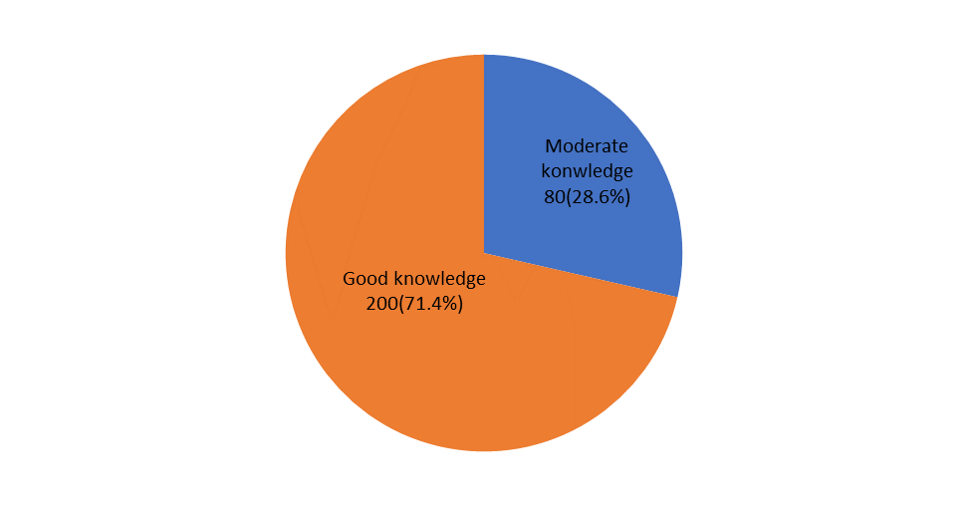
Fig. I: The composite knowledge of management of Type 2 diabetes mellitus among the respondents

Respondents’ dietary practices
Figure 2 shows that 215 (76.8%) of the respondents demonstrated high extent of practice of dietary practices, 43 (15.4%) demonstrated moderate practice while 22 (7.8%) demonstrated low level of practice. The mean practice is (3.03±0.826). Table 3 shows that most of the respondents adhere strictly to dietary modification (3.34±1.045), not eating frequently in fast food restaurant (3.08±0.797), not taking meals once in day (3.18±0.763), not taking meals two times in day (3.08±0.806), taking meals three times in day (3.54±.0.950), skipping breakfast (3.16±0.741), skipping lunch (3.28±0.753), skipping dinner (3.14±0.750), preferred boiling method of cooking (3.46±0.983), and not preferred frying method of cooking (3.16±0.694).
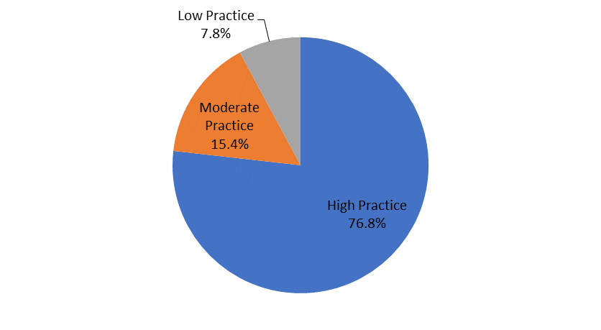

Fig. 2: The composite dietary practices among the respondents
Test of Hypothesis
Ho₁: There is no significant relationship between the patients’ knowledge of management of diabetes and dietary practices among type2 diabetes mellitus patients attending Consultant Out-patients Department of University of Benin Teaching Hospital Edo State.
Relationship between respondents’ knowledge of management of diabetes and dietary practices using Pearson chi-square at 0.05 level of significance
Since the computed chi-square value χ² = 9.731 at degree of freedom (df) 2 is greater than the critical value of 5.991 at 0.05 level of significant, there is statistically significant evidence to reject the null hypothesis. This means there is statistically significant relationship (P = 0.007) between the patients’ knowledge of management of diabetes and dietary practices among type2 diabetes mellitus patients attending Consultant Out-patients Department of University of Benin Teaching Hospital Edo State.

DISCUSSION
This study assessed the knowledge and practice of self-care among type 2 diabetes mellitus attending consultant out-patients department of University of Benin Teaching hospital, Edo state Nigeria.
Respondents Characteristics
The mean age of the most diabetic group reported in this study as 52 ± 4.351 (140%) is consistent with the study by Mukanoheli, et al., ⁸ and is at variance with (18-34years) as reported by Abate et al.⁹ This difference is likely due to variability of the study participant and location of the various studies. Reports from the IDF,¹⁰ has shown the age range of 40-59 as having the highest percentage of diabetes. This is probably due to the fact that age is a risk factor for diabetes as reported by Yan et al. ¹¹ According to Kautzky-Willer et al., ¹² globally, there is about 17.7 million of more men with diabetes compared to women. However, the women seem to have a higher risk factor especially as related to type 2 diabetes which is obesity. Furthermore, there is also the sociopsychological stress factor that predisposes women to diabetes risk. Pregnancy related hormonal and body changes overtime in women is also a risk factor.¹² Gestational diabetes is also a risk factor for women as it often times progresses to type 2 diabetes in women.¹² Despite the report of diabetes more prevalent in men globally, the greater number of elderly women in numerous populations including our study area could be a reason for more female (184) than male (96) in this particular study. This is consistent with similar gender distribution reported by Olaoye and Aina.¹³ Furthermore, about 45.7 % of the respondents in this study had diabetes for over 10 years, while 28.2% and 26.1% respectively have been diabetic for 6-10 years and 0-5 years respectively. This is likely due to the relationship between diabetes, dietary and lifestyle changes. Lambrinou et al.,¹⁴ identified dietary modification as a vital aspect in diabetes management due to its association with improved glycemic control. Furthermore, duration of diabetes has a strong positive influence on self-care knowledge. Longer duration of diabetes likely increases the chances for exposure to information about diabetes.
Knowledge of management of diabetes mellitus among Type 2 diabetes patients attending Consultant Out-patients Department of University of Benin Teaching Hospital Edo State
Generally, the knowledge on the management of diabetes among the respondents in this study is high. However, the respondents showed poor knowledge on the use of items such as the use of drinking of excess water and slight alcohol consumption in the management of diabetes. Studies have shown that low water intake is linked with increased diagnosis of high blood sugar.¹⁵ This therefore implies that patients who do not know the importance of water as regarding diabetes management may easily neglect lots of water intake. This is consistent with the findings of Nwaomah, et al.¹⁶ A possible reason for the good knowledge evidenced in this study could be due to the fact that majority of the respondents had tertiary education which makes it easier to seek further knowledge on health matters by individuals or it could be attributed to detailed health education delivered to patients by health care providers in tertiary health institutions.
Furthermore, findings from this study showed a high level of dietary practices among type 2 diabetes mellitus patients in this study. This is consistent with the findings of Olatona et al., ¹⁷ but inconsistent with the that of Okunlola, ¹⁸ who showed poor dietary practice. Level of education and socio-economic status of the respondents may have in one way or the other contributed to the findings of these studies.
A high rate of complementary / alternative medicine use has been reported among people with diabetes. This study revealed that type 2 diabetes patients attending Consultant Out-patients Department of University of Benin Teaching Hospital Edo State have good knowledge of management of diabetes mellitus (3.11 ± 0.896). This is consistent with the findings of Nwaomah, et al.¹⁶ The good knowledge evidenced here could be due to the fact that majority of the patients had tertiary education which makes it easier to seek further knowledge on health matters by individuals or it could be attributed to detailed health education delivered to patients by health care providers in tertiary health institutions. This is well explained by Jackson et al.,¹⁹ who noted that educational status influences the self-care knowledge among diabetic patients.
CONCLUSION
Diabetes self-care knowledge and practice was moderate among the population studied. The status of education, occupation and duration of illness all predicted the knowledge level. Therefore, it is recommended that continue health education should be given to diabetes patients in other to sustain the moderate knowledge and high practice. Health care providers should constantly educate patients about the goals of therapy, the purpose of each drug prescribed, the importance of adhering to every prescribed medication as well as the consequences of nonadherence. Patients should be taught and constantly reminded that diabetes cannot be cured but can be well-managed if adherence to treatment is high.

REFERENCES
- International Diabetes Federation. Diabetes Atlas, 14th Edition 2021. https://www.diabetesatlas.org Accessed 15th January 2022
- Hashim ZP. The health beliefs and perception of adults living with diabetes type 2 in Nigeria. European Journal of Medical and Health Sciences 2020; https://doi.org/10.24018/ejmed.2020.2.5.468 7th .
- Ugwu E, Young E, Nkpozi M. Diabetes care knowledge and practice among primary care physicians in South-East Nigeria: A cross-sectional study. BMC Fam Pract 2020; 21, 128 https://doi.org/10.1186/s/12875-020-01202-0

- Uloko AE, Musa BM, Ramalan MA, Gezawa ID, Puepet FH, Borodo MM, Sada KB. Prevalence and Risk Factors for Diabetes Mellitus in Nigeria: A Systematic Review and Meta-Analysis. Diabetes Ther. 2018;9(3):1307-1316. doi: 10.1007/s13300-018-0441-1. PMID: 29761289; PMCID: PMC5984944.
- Garcia-Perez I, Posma JM, Gibson R, Chambers ES, Hansen TH, Vestergaard H, Hansen T, Beckmann M, Pedersen O, Elliott P, Stamler J, Nicholson JK, Draper J, Mathers JC, Holmes E and Frost G. Objective assessment of dietary patterns by use of metabolic phenotyping: a randomised, controlled, crossover trial. Lancet Diabetes Endocrinol. 2017;5(3):184-195. doi: 10.1016/S2213-8587(16)30419-3. PMID: 28089709; PMCID: PMC5357736.www.wjpr.net Vol 6, Issue 10, 2017. 92- 0034-y
- World Health Organization. ‎. Global reference list of 100 core health indicators (‎plus health-related SDGs)‎. World Health Organization. 2018 https://apps.who.int/iris/handle/10665/259951. License: CC BY-NC-SA 3.0 IGO
- Sami W, Tahir A, Mohd Rashid Ab Hamid. A review effect of diet on type 2 diabetes mellitus: Int J Health Sci (Qassim).2017; 11(2): 65–71.PMCID: PMC5426415 PMID: 28539866
- Mukanoheli V, Uwamahoro MC, Mbarushimana V, Meharry P. Functional Health Literacy and Self-Care Behaviors Among Type 2 Diabetic Patients at a University Teaching Hospital in Kigali. Rwanda J Med and Health Sci 2020;3 (1) https://dx.doi.org/10.4314/rjmhs.v3i1.7
- Abate TW, Tareke M, Tirfe M. Self-care practices and associated factors among diabetes patients attending the outpatient department in Bahir Dar, Northwest Ethiopia. Abate et al. BMC Res Notes 2018; 11:800 https://doi.org/10.1186/s13104-018-3874-8
- International Diabetes Federation 2023: Global burden of diabetes. IDF Diabetes Atlas, 5th edition. Available from: https://idf.org/about-diabetes/diabetes-facts-figures/ (Accessed 9th October, 2023).
- Yan Z, Cai M, Han X, Chen Q, Lu H. The Interaction Between Age and Risk Factors for Diabetes and Prediabetes: A Community-Based Cross-Sectional Study. Diabetes, metabolic syndrome and obesity: targets and therapy,2023; 16, 85–93. https://doi.org/10.2147/DMSO.S390857
- Kautzky-Willer A, Leutner M, Harreiter J. Sex differences in type 2 diabetes. Diabetologia, 2023;66(6), 986–1002. https://doi.org/10.1007/s00125-023-05891-x
- Olaoye T. Aina M. Self-Care Related Knowledge and Self-care Practices among Type 2 Diabetic Patients Attending Selected Hospitals in Oyo State, Nigeria. International Journal of Caring Sciences. 2022; 15(2): 1258-1267
- Lambrinou E, Hansen TB, Beulens JW. Lifestyle factors, self-management and patient empowerment in diabetes care. Eur J Prev Cardiol. 2019;26(2):55-63.
- Johnson EC, Bardis CN, Jansen LT, Adams JD, Kirkland TW, Ka-vouras SA. Reduced water intake deteriorates glucose regulation in patients with type 2 diabetes. Nutr Res. 2017 Jul; 43: 25-32. doi:10.1016/j.nutres.2017.05.004.
- Nwaomah, EE, Agharanya UB, Okueso GO, Solanke AA, Wennie SJ. Knowledge of self-care management and diabetic control among patients with diabetes mellitus type 2 in Randle General Hospital. Amer J of Sci and Engr Res, 2021;3 (5): 19-28
- Olatona FA, Sosanya A, Sholeye OO, Obrutu OE, Nnoaham KE. Fruits and vegetable knowledge, consumption pattern and associated factors among adults in Lagos, Nigeria. Res. J. of Health Sci. 2018; 6(2): 50-62
- Okunlola, RC, Abu SJ, Joseph BN, Damun PA, Selowo TT, Dapar MP. Dietary knowledge, attitudes and practices: a cross-sectional survey of type 2 diabetic patients in two tertiary hospitals in Jos, Nigeria. J Pharm & Biores 2022; 19(1):1-8
- Jackson IL, Adibe MO, Okonta MJ, Ukwe CV. Knowledge of self-care among type 2 diabetes patients in two states of Nigeria. Pharm Pract (Granada). 2014;12(3):404. doi:10.4321/s1886-36552014000300001

