**Correlation Between the Morphometric Parameters of Occipital Condyles, Foramen Magnum and Biparietal Diameter on Skull CT Images**

* Ominde B.S. and Igbigbi P.S

Department of Human Anatomy and Cell Biology, Faculty of Basic Medical Sciences, Delta State University, Abraka, Nigeria



*Corresponding author email: [berylominde@gmail.com](mailto:berylominde@gmail.com)

Doi: https://doi.org/10.21816/ijf mi.v5i1

QR CODE

**ABSTRACT**

**Introduction**: Estimation of dimensions of the craniovertebral junction is important in the planning of neurosurgical procedures of the posterior cranial fossa. This study aimed at determining the association between the occipital condyles (OC) and foramen magnum (FM) dimensions with the biparietal diameter (BPD) in adult Nigerians.

**Materials and Methods**: Brain computed tomography images of 336 adults were retrospectively analyzed in the Radiology department of a Teaching Hospital after obtaining ethical approval. The BPD, OC and FM dimensions were measured and the data analyzed using Statistical Package for Social Sciences version 23 then summarized in means and standard deviations. Pearson’s correlation test was used to establish an association between the measurements and this was considered significant at p <0.05.

**Results**: Significant gender differences were observed in the OC and FM measurements. There was also significant correlation between FM and OC widths; FM width and BPD, intercondylar and bicondylar distances; BPD and the intercondylar and bicondylar distances; and lastly the FM length and distance from the anterior tips of the OC to the opisthion (p<0.05).

**Conclusion**: The significant gender differences in the OC and FM measurements should be considered during the planning of CVJ surgeries. Although significant, the correlations between the OC, FM and BPD dimensions were weak hence the need for preoperative radiologic measurement of these variables by surgeons in the studied population to avoid complications.

**Key-words**: Foramen magnum, occipital condyle, biparietal diameter

**INTRODUCTION**

The occipital condyles (OCs) are bean shaped structures bordering the foramen magnum (FM) bilaterally and articulate with the first cervical vertebrae (atlas) at the atlanto-occipital joint (AOJ). 1,2 They are a constituent of the cranio-verterbral junction (CVJ) and permit flexion and extension. 3 The FM is an aperture located at the center of the skull base which is formed by the fusion of four parts of the occipital bone including the pars squama, left and right pars lateralis and pars basilaris. 4 The anterior and lateral parts of the FM form from three synchondroses, namely; basioccipital, exoccipital and their interoccipital synchondroses. The posterior part develops from supraoccipital, exoccipital and the corresponding interoccipital synchondroses. From the exoccipitalis portion, the two OC are formed. 5 The complete fusion of these parts occurs after the development of the central nervous system which is experienced between 5 and 7 years of age. 6 The sagittal growth of the FM is 5.4% greater than the horizontal growth from the 7th month in-utero to birth. Subsequently, from birth to six months, the transverse growth is more than the anteroposterior growth by 7.6%. Thereafter, maximum diameters are attained by the age of 10 years. 5

The calvarium or cranial vault consists of flat bones, namely; frontal, parietal, squamous temporal and occipital bones. 7According to Jin et al.,7 the prenatal development of the cranial vault consists of three phases namely; the embryonic phase characterized by the condensation of the mesenchyme from the paraxial mesoderm, the fetal phase where intramembranous ossification of the skull and the formation of cranial sutures occur and lastly, bone remodeling phase. These authors also expound that postnatally, the cranial vault grows following the proliferation of the connective tissue in the sutures and the simultaneous growth of the skull base

The CVJ has a sensitive location which poses a great challenge during surgery. Its anatomy is very important owing to the recent advent of minimally invasive neurosurgical procedures. 3 The vital structures associated with the CVJ include the medulla oblongata, spinal cord, upper spinal nerve, vertebral arteries, meningeal branch of ascending pharyngeal artery and the last four cranial nerves (IX-XII). 8 These structures are prone to inadvertent injury during surgery leading to serious complications such as haemorrhage, AOJ instability and hypoglossal nerve injury. 3,9

The dimensions of the OC and FM show population, racial and gender differences. 10-12 The knowledge of these dimensions is important to radiologists and neurosurgeons in the planning of the surgical management of the posterior cranial fossa lesions located ventral to the brainstem and at the cervico-medullary junction. 11,13,14 These metric parameters aid in determining the most suitable neurosurgical technique/approach and the extent of condylar drilling. 2 The dimensions of the FM are important in clinical conditions such as meningiomas, hydrocephalus, bulbar tumours, herniation of the brain and achondroplasia. 15-18 The lateral approach in CVJ surgery requires the resection of the OC.1 The transcondylar approach (TCA) involves additional condylar drilling to increase the surface area for safe access to the middle and posterior cranial base structures such as CVJ, FM and brainstem.11 According to Singh et al., 19 the FM is used as a landmark for safe OC resection.

The estimation of the OC dimensions from FM parameters and vice versa or their approximation from the biparietal diameter (BPD) may guide the surgeon during preoperative planning and help predict any surgical challenges. To the best of our knowledge, there is dearth of data regarding the correlation between these metric parameters in Delta State Nigeria. Accordingly, this study aimed at determining the correlation between the dimensions of the OC, FM and the BPD using brain computed tomography (CT) images of adult Nigerians, stored in the archives of a Teaching Hospital in Delta State.

## MATERIALS AND METHODS

We retrospectively performed this cross-sectional study at the Radiology department of Delta State University Teaching Hospital, Nigeria. Approval for the study was granted by the Hospital’s Ethics and Research committee (EREC/PAN/2020/030/0371). The purposive sampling technique was adopted in this study. Brain CT images of patients who visited the Radiology unit between 1st June 2015 and 30th June 2020 for reasons such as headache, and suspected stroke or space occupying lesions were retrieved from the Picture Archiving Communications Systems (PACS) database. These images were acquired using a 64 slice CT scanner (Toshiba Aquilon, Japan) at 120kV and 300mA. The inclusion criteria comprised CT images with complete demographic data (age and gender) and both male and female patients aged 20 years and above. We excluded poor quality images with artefacts such as motion or beam artefacts, images with evidence of pathological lesions, trauma or previous surgery on the skull base and cranial vault. Therefore, CT images of 336 adult patients; 199 males and 137 females fit our inclusion criteria.

Using bone window, the FM and OC were identified on the base of skull. All the measurements were carried out on the axial images of the skull using a digital caliper provided by PACS. The metric parameters of the OC and FM were measured following the descriptions by Rai et al. 10 and Ominde and Igbigbi.12 The length of the FM was measured as the anteroposterior distance between the basion and the opisthion on midsagittal plane while the maximum transverse diameter perpendicular to the length was considered as the FM width.

The length of the OC was measured as the maximum distance between its anterior and posterior poles while its width was measured as the greatest mediolateral distance perpendicular to the length (Figs 1A, 1B)

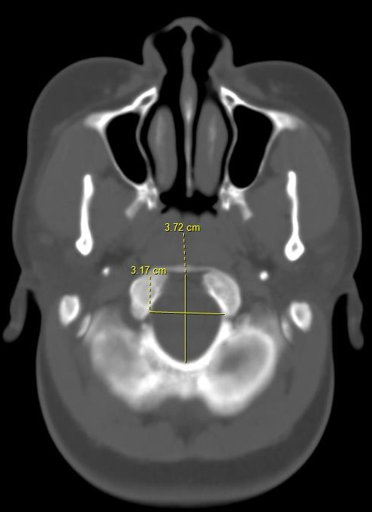 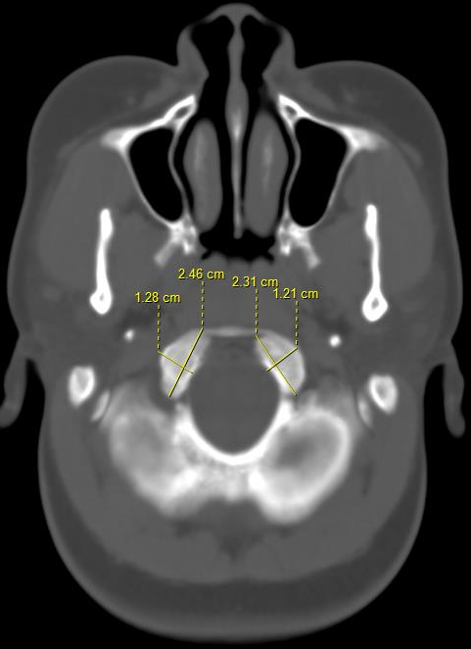

A B

**Figure 1** Computed Tomography images showing the measurement of; A. Anteroposterior and transverse dimensions of the foramen magnum B. The length and width of the occipital condyle

The minimum and maximum transverse distances between the medial edges of the condylar articular margins were labelled the minimal medial intercondylar distance (Min MID) and maximum medial intercondylar distance (Max MID) correspondingly. The maximum horizontal distance between the right and left OC articular surfaces was regarded as the maximum bicondylar distance (Max-BCD) (Fig. 2).

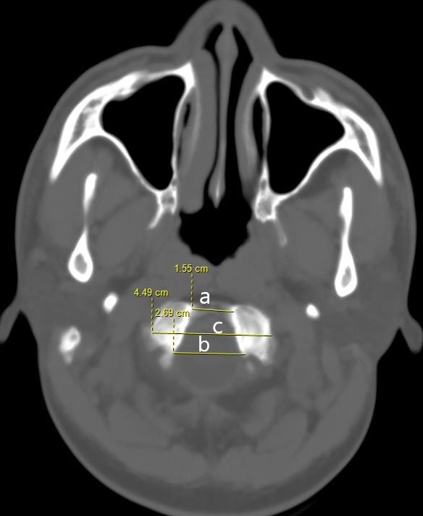

**Figure 2** Computed Tomography image showing the measurement of; Minimum medial intercondylar distance (a), maximum medial intercondylar distance (b) and maximum bicondylar distance (c)

The anterior and posterior tips of the OC were measured from the basion (Ant-Ba, Post-Ba) and opisthion (Ant-Opisth, Post-Opisth) of FM on axial sections (Figs. 3A and B). Biparietal diameter was measured as the maximum transverse diameter between the most projecting points on either side of the skull on axial plane (Fig. 4).

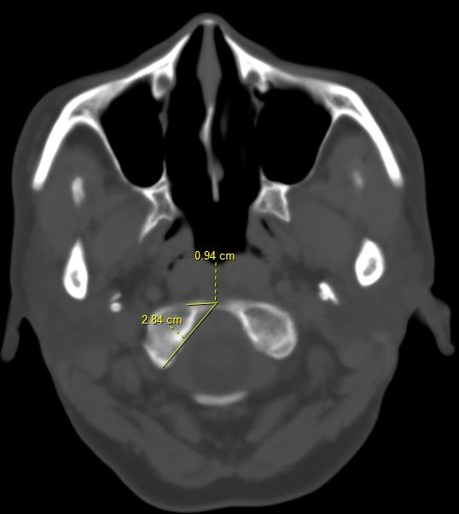 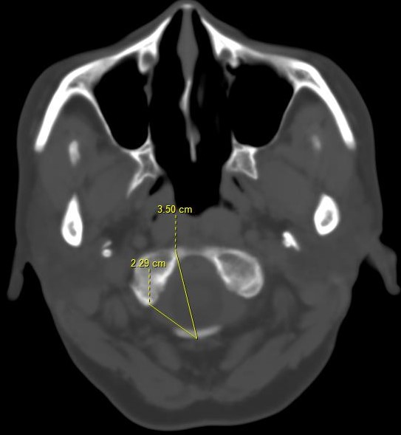

**A B**

**Figure 3** Computed Tomography images showing the distance from the anterior and posterior tips of the occipital condyle to the basion (A) and opisthion (B)

## C:\Users\HP\Desktop\extra manuscripts\FM and OC\int j forensic med investiga\Corrections\pics\Figure 4 Computed Tomography images showing the measurement of the biparietal diameter.jpg

**Figure 4** Computed Tomography image showing the measurement of the biparietal diameter

Data analysis was accomplished using Statistical Package for Social Sciences (SPSS) version 23 (IBM Corporation, Armonk, New York, USA) and summarized in means and standard deviations. Independent t test was used to probe for gender

differences in the variables while Pearson’s correlation test was used to establish an association between the measurements of the FM, OC and BPD. A P value of <0.05 was considered statistically significant.

## RESULTS

Brain CT images of 336 adult patients were sampled for use in this study. These comprised images of 199 (59.2%) males and 137 (40.8%) females who were aged between 20 years and 99 years and with an average age of 53.29±18.18 years. The mean BPD and the average dimensions of the OC and FM are shown in Table 1. Most of these metric parameters showed significant gender differences except Ant-Ba and Min-MID. Moreover, the BPD did not show a statistically significant association with gender (*P* 0.868) (Table 1).

**Table 1**. Morphometric parameters measured



*Significance considered at P<0.05. SD- standard deviation.

The FM width showed a significant weak negative correlation with OC width and a significant weak positive correlation with BPD, Min-MID, Max-MID and Max-BCD in the studied population (P <0.05). In males, the FM width showed a significant strong positive correlation with BPD, Min-MID, Max-MID and Max-BCD and a significant weak negative correlation with the OC width. Conversely, the FM width in females had a significant weak positive correlation with BPD. This study reports a significant weak positive correlation between BPD and the intercondylar and bicondylar distances in the study sample and in females. These correlations in the males, were strong positive and statistically significant (P <0.05). The AP diameter of the FM showed a significant weak positive correlation with the Ant-Opisth distance in the studied population and in males (P <0.05) (Tables 2-4).

**Table 2** Correlation between the morphometric parameters in the studied population



r- Pearson’s correlation coefficient.

16

**Table 3** Correlation between the morphometric parameters in male

r- Pearson’s correlation coefficient.

**Table 4** Correlation between the morphometric parameters in females

r- Pearson’s correlation coefficient

DISCUSSION

The metric parameters evaluated in this study varied from previously documented literature reports. 1-4,8-11 This study reports significantly larger OC and FM measurements in males than in females and this has been ascribed to the gender differences in genetics, hormones, robusticity of muscles, environmental factors, diet and socioeconomic activities. The sexual dimorphism should therefore be considered during the planning of CVJ and posterior cranial fossa surgeries 12,20

We observed a significant weak negative correlation between FM width and OC width in the studied sample and in males. This implies that larger FM width is associated with smaller OC width and vice versa in our population. Developmentally, the faster transverse growth of the FM in the last trimester could explain this negative correlation whereby, the increase in FM width interferes with the transverse growth of other parts of the occipital bone such as the OC. The FM therefore invaginates into the occipital bone leading to the protrusion of the OC into it. 5 On the contrary, Abo El-Atta et al. 21 in their evaluation of 367 adult CT images in Egypt documented a significant weak positive correlation between the width of FM and the right OC width in

males and both OC widths in females. In Iran, Bayat et al. 1 reported a positive correlation between the OC width and FM

dimensions on 50 adult dry skulls. They also observed a positive correlation between OC width and FM circumference. According to these scholars, this relationship inferred that the size of the OC width is dependent on the lateral movement of the antlantooccipital joints and FM size. However, in Sudan, Salih et al. 22 reported no correlation between OC width and FM dimensions on CT images. According to Mahajan et al., 23 a patient with small FM and large OC requires condylar drilling by TCA for more extensive bony resection. Narrow OC are associated with atlantooccipital joint instability. 14 The knowledge of this correlation is important before TCA to the craniovertebral junction for safe OC resection.

There was a significant weak positive correlation between FM width and the intercondylar and bicondylar distances in the studied sample. In males, statistically significant strong positive correlations between these parameters were observed. These findings perhaps propose that the larger the FM width the bigger the intercondylar and bicondylar distances. Congruent with our findings, the CT analysis of the OC and FM in Sudan revealed a significant positive correlation between FM parameters (length and width) with maximum and medial intercondylar distances and bicondylar distance. 22 Furthermore, El Baranny et al. 24 evaluated CT images of 400 adult Sudanese and documented a significant positive correlation between maximum medial intercondylar distance and the FM width. Using dry skulls of Greek descent, Lyrtzis et al., 6 documented a strong positive relationship between the FM transverse diameter and the posterior intercondylar distance. Correspondingly, Abo El-Atta et al. 21 in Egypt documented a significant weak positive correlation between FM width and the maximum bicondylar distance among the adult females. According to Agarwal et al., 2 the large intercondylar distances in males are attributable to their wider FM compared to females. The positive correlations between FM width and the intercondylar distances helps the surgeons to estimate the intercondylar distances using the FM width. This will aid in the preoperative planning since wider intercondylar distance is associated with less extensive condylectomy and better accessibility of the craniovertebral junction lesions. 3,11

The weak positive association between the length of the OC and the FM dimensions was not statistically significant in our study. This contrasted with Salih et al. 22 who reported a significant weak positive correlation between the FM parameters and the OC length. A Turkish study by Naderi et al. 25 analyzed the linear dimensions of the OC on 202 adult skulls and documented a weak positive correlation between OC length bilaterally with the AP diameter of the FM and these were statistically significant. Among the Egyptians, Abo El-Atta et al. 21 documented a significant weak positive correlation between FM width and the right OC length in females. The association between the FM dimensions and the OC length helps surgeons to estimate the size of the OC length from the FM. This informs the surgeon on the extent of condylectomy since the OC length is vital in occipito-cervical stability. 9 In this study population therefore, the FM dimensions may not accurately be used to estimate the OC length.

The significant positive correlation between the FM width and

17

BPD perhaps suggests that skulls with larger BPD are associated with wider FM. Furthermore, we observed a significant positive correlation between BPD and the intercondylar and bicondylar distances possibly suggesting that the BPD increases with an increase in these distances. These findings imply that the transverse neurocranial parameters such as BPD positively correspond to the transverse dimensions of the skull base, perhaps signifying a homogenous growth between these two parts of the skull bone. The strong positive correlations observed in the males suggest that the BPD which can be externally measured, may accurately be used to approximate the deeply located skull base transverse dimensions (FM width, intercondylar and bicondylar distances) for safe surgery in males.

The BPD in our study did not show any significant correlation with the OC length and width. Consistent with our findings, Salih et al. 22 in Sudan, also reported that the transverse and sagittal head diameters did not show any significant relationship with the OC dimensions. Based on these findings, these scholars implied that the achievement of condylectomy should not be determined by the head diameters. 22 On the contrary, Bayat et al. 1 documented a significant strong positive relationship between the circumference of the head and the OC width but not with OC length. According to Naderi et al., 25 the length of the bilateral OCs in Turkish adult skulls showed weak positive correlations with the head circumference, however, these were not statistically significant. They concluded that a surgeon cannot predetermine how challenging or easy condylectomy would be based on the size of the head.

The AP diameter of the FM in the current study showed a significant weak positive correlation with the Ant-Opisth distance. This was significant in the studied population and only in males suggesting that this distance is larger in skulls with longer AP diameter of the FM hence providing a greater surgical corridor during approach to the craniovertebral junction.

It is evident that the correlations observed in our study varied from some previous literature reports. This study attributes these discrepancies to the differences in genetics, race, geographical and environmental factors that influence the skull development. The dissimilarities in the sample size, and methodology; CT versus direct measurement on skull bone may also contribute to these variations. The significant strong positive correlations observed in males but not in females correspond to the gender difference in the growth and remodelling of the skull which are mainly dependent on genetics and hormonal factors. [10]

**Conclusion**

The significant gender differences in the OC and FM measurements should be considered during the planning of CVJ surgeries. Although significant, the correlations between the OC, FM and BPD dimensions in the studied population were weak and this emphasizes the need for their preoperative radiologic measurements to avoid complications. We suggest a future multi-centered study with a larger sample size to ascertain our findings. This will aid in safe CVJ surgeries with better outcomes in our population.

**Limitation of Study**

The study adopted a purposive sampling technique and used images from a single centre. Therefore, these findings may not be generalized.

**Conflict of Interest**: None

**Acknowledgements**: We would like to acknowledge Priscilla Ejiroghene, and Dr. Jaiyeoba-Ojigho Jennifer Efe who assisted with data collection and data analysis respectively.

## REFERENCES

1. Bayat P, Bagheri M, Ghanbari A, Raoofi A. Characterization of occipital condyle and comparison of its dimensions with head and foramen magnum circumferences in dry skulls of Iran. Int J Morphol. 2014; 32(2):444-448.
2. Agarwal RK, Sharma AR, Gupta V. Morphometric investigation of occipital condyles and its relevance in transcondylar approach: An observational study in western Uttar Pradesh region. MedPulse – Int J Anatomy. 2019; 11(2):39-43.
3. Farid SA and Fattah IO. Morphometric study of human adult occipital condyle, hypoglossal canal and foramen magnum in dry skull of modern Egyptians. Intl J Clin Dev Anat. 2018; 4(1):19-26.
4. Ganapathy A, Sadeesh T, Rao S. Morphometric analysis of foramen magnum in adult human skulls and CT images. Int J Cur Res Rev. 2014; 6(20):11-15.
5. Zdilla MJ, Russell ML, Bliss KN, Mangus KR, Koons AW. The size and shape of the foramen magnum in man. J Craniovert Jun Spine. 2017; 8:205-21.
6. Lyrtzis C, Piagkou M, Gkioka A, Anastasopoulos N, Apostolidis S, Natsis K. Foramen magnum, occipital condyles and hypoglossal canals morphometry: Anatomical study with clinical implications. Folia Morphol. 2017; 76(3):446-457.
7. Jin S, Sim K, Kim S. Development and growth of normal cranial vault: An embryonic review. J Korean Neurosurg Soc. 2016;59(3):192-196.
8. Bosco A, Venugopal P, Shetty AP, Shanmuganathan R, Kanna RM. Occipital condyle-based occipitocervical fixations in Indians. Asian Spine J. 2018; 12(2):214-223.
9. Ilhan P, Kayhan B, Erturk M, Sengul G. Morphological analysis of occipital condyles and foramen magnum as a guide for lateral surgical approaches. MOJ Anat Physiol. 2017; 3(6):188-194.
10. Rai H, Keluskar V, Patil S, Bagewadi A. Accuracy of measurements of foramen magnum and occipital condyle as an indicator for sex determination using computed tomography. Indian J Health Sci Biomed Res. 2017; 10(1):80-83.
11. Aristotle S, Ramraj B, Patil S, Subramanian S. Anatomical and radiological study of the posterior cranial base in relationship to occipital condyles and foramen magnum. Int J Res Pharm Sci. 2020; 11(3):3528-3532.

18

1. Ominde BS, Igbigbi PS. Morphometry of the occipital condyles in Adult Nigerians. Online J Health Allied Scs. 2021;20(4):10
2. Sholapurkar VT, Virupaxi RD, Desai SP. Morphometric analysis of human occipital condyles for sex determination in dry adult skulls. Int J Anat Res. 2017; 5(1):3318-3323.
3. Cheruiyot I, Mwachaka P, Saidi H. Morphometry of occipital condyles: Implications for transcondylar approach to craniovertebral junction lesions. Anat J Afr. 2018; 7(2):1224 - 1231.
4. Burdan F, Szumiło J, Walocha J, Klepacz L, Madej B, Dworzański W, et al. Morphology of the foramen magnum in young Eastern European adults. Folia Morphol. 2012; 71(4):205–216.
5. Eboh DE. Morphometric and morphological study of foramen magnum in dry adult skulls in a Southern Nigerian population. J Anat Sci. 2014; 5(1):48-53.
6. Naqshi BF, Shahdad S, Kawoosa N, Shah AB. Morphological and morphometric study of foramen magnum in dry human skulls of Kashmir. Glob J Res Anal. 2017; 6(8):1-3.
7. Lucena JD, Sanders JV, Brito HM, Cerqueira GS, Silva IB, Oliveira A. Morphometric analysis of the foramen magnum in dry human skulls in North-Eastern Brazil. J Morphol Sci. 2019; 36(2):97–104.
8. Singh KC, Rai G, Rai R. Morphological variations of the foramen magnum in adult human dry skull in Eastern UP (India) population. Int J Med Res Prof. 2017; 3(2):205-208.
9. Ominde BS, Igbigbi PS. A retrospective study to evaluate the morphometry of the foramen magnum and its role in forensic science in a Nigerian population of Delta State. J Forensic Sci Med 2021; XX: XX-XX.
10. Abo El-Atta HM, Abdel-Rahman RH, El-Hawary G, Abo El-Al-Atta HM. Sexual dimorphism of foramen magnum: An Egyptian study. Egypt J Forensic Sci. 2020; 10(1):1-12.
11. Salih AM, Ayad CE Abdalla EA. Characterization of occipital condyles in Sudanese using computerized tomography. Glob Adv Res J Med Med Sci. 2014; 3(12):437-444.
12. Mahajan D, Agnihotri G, Sheth A, Brar R. An anatomical perspective of human occipital condyles and foramen magnum with neurosurgical correlates. Anatomy. 2012-2013; 6(7):29-33.
13. El-Barrany UM, Ghaleb SS, Ibrahim SF, Nouri M, Mohammed AH. Sex prediction using foramen magnum and occipital condyles computed tomography measurements in Sudanese population. Arab J Forensic Sci Forensic Med. 2016; 1(3): 414-423.
14. Naderi S, Korman E, Cıtak G, Guvencer M, Arman C, Senoglu M. Morphometric analysis of the Human Occipital condyle. Clin Neurol Neurosurg. 2005; 107(3):191–199.