**Effect of verapamil on haematological parameters and lung oxidative profile in mice subjected to hypoxia**

* Eduviere A. T, Otomewo L. O, Egerega E. V and Charles E. O

Department of Pharmacology, Faculty of Basic Medical Sciences, Delta State University, Abraka, Nigeria

**INTRODUCTION**

Respiration is the core feature of living things that separates them from non-living things. In humans, respiration is possible due to the normal functioning of various internal structures in the presence of oxygen.1 Therefore, the lungs are the major players in the respiratory system which is tasked with the oxygenation of blood and gaseous exchange across membranes, while the blood is the specialized fluid-tissue of the circulatory system that transports deoxygenated blood to the lungs for oxygenation and transports oxygenated blood to all tissues of the body in order to ensure proper cellular functioning. However, the inability to get enough oxygen into the lungs raises the risk for developing hypoxia.2

Hypoxia, also known as oxygen deprivation, is a condition that results due to unavailability of adequate oxygen for the cells and tissues in the body. It can be a result of staying in environments that are low in environmental oxygen (such as high altitudes, deep seas), overcrowded places or in polluted areas.3 For this reason, various substances have been investigated for possible benefit in attenuating tissue damage in people who undergo chronic hypoxic stress. For this reason, this research seeks to evaluate the effects of chronic oxygen deprivation on the blood as well as lungs of mice and the possible benefit of a calcium channel blocker, verapamil.

## MATERIALS AND METHODS

## Thirty (30) male Swiss mice (24.0±2.0 g) used in this research were acquired from the animal firm of in faculty of the affiliated institution. Following procurement, the mice were accommodated in rectangular transparent cages at room temperature with equal hours of exposure to light and darkness. Also, the mice were allowed balanced rodent diet and water at liberty. Worthy of note is that the research was carried out while adhering strictly to the NIH laid-down protocols for animal experimentation.

## Verapamil (120 mg) was dissolved 12 mL of distilled water to obtain the stock solution (10 mg/mL) and was diluted further with to obtain the various concentrations used in this research. Subsequently, mice were orally treated with either verapamil (10, 20, 40 mg/kg, p.o.), or distilled water (10 mL/kg, p.o.), using an oral cannula. Therefore, the animals were apportioned into five (5) treatment groups of six animals each (n = 6):

## Groups 1 (non-stress control) was given 10 mL/kg distilled water only;

## Group 2 (stress control) received 10 mL/kg distilled water post-exposure to stress;

## Groups 3 received 10 mg/kg verapamil post-exposure to stress;

## Group 4 was given 20 mg/kg verapamil post-exposure to stress;

## Group 5 was given 40 mg/kg verapamil post-exposure to stress.

## For the total treatment period of seven (7) consecutive days, stress was induced in mice by the induction of hypoxia. One hour after oral administration of distilled water or verapamil, mice in groups 2–5 were subjected to hypoxic stress by placing them respectively and exclusively in a proper airtight cylindrical vessel of 250 mL volume for 20 min daily for the entire period of treatment protocol, i.e., seven days.4,5 Then 24 h after, blood tests and lung biochemical assays were conducted. Also, lungs histology was carried out.

## Blood samples were collected by cardiac puncture into ethylene diamine-tetra-acetic acid (EDTA) tubes. Consequently, a full blood count including white blood cell count, red blood cell count, haemoglobin content estimation, packed cell volume (PCV), mean corpuscular volume (MCV), mean corpuscular haemoglobin concentration (MCHC) was carried out manually on the samples in accordance with previously described routine methods.6

## Following euthanization, each mouse lung was harvested, weighed and homogenized with 0.1M phosphate buffer (pH 7.4) and cold centrifuged (at 10,000 rpm) for 15 min. Then, the supernatants of each lung were used for the various biochemical assays.

## Aliquots of lung supernatant of individual mouse in the respective treatment groups were taken and glutathione concentration (GSH; micromole/g tissue)7, malondialdehyde content (MDA; micromole/g tissue)8, superoxide dismutase activity (SOD; unit/mg protein)9, catalase activity (CAT; unit/mg protein)10, nitric oxide concentration (NO; μM)11, and myeloperoxidase activity (MPO; unit/mg protein) were determined according to previously established methods.12,13

## Lung tissue obtained from mice in each group was fixed in 10 % phosphate buffered formaldehyde used for perfusion. The transverse sections (5–6 µm thick) of the lungs were then obtained using a microtome (Leica, Germany) and processed by the routine method for paraffin wax embedment for histology. The histological staining with H&E was carried out in paraffin wax embedded sections for cell quantification as earlier described by Emokpae et al.14 and the sections were fixed on glass slides for microscopy and photomicrography.

## All data obtained were presented as Mean ± S.E.M. The

## results were analysed by one-way ANOVA and followed by Bonferroni’s Multiple Comparison test. The GraphPad Biostatistics software (version 7) was then used to determine the degree of significance, which was set at p <0.05 for all tests.

## RESULTS

**Table 1: Effect of verapamil on blood volume parameters of mice subjected to hypoxic stress**

**Changes in content of blood components of mice subjected to hypoxia**

Hypoxic stress in mice initiated a significant increase in white blood cell counts (Figure 1a) and a significant decrease in red blood cell count (Figure 1b) and haemoglobin content (Figure 1c) as seen in the stress control groups when compared to the non-stress controls. However, these effects were significantly reversed by verapamil in a manner depicting dose-dependence.



**Figure 1a: Effect of verapamil on white blood cell count in mice subjected to hypoxic stress**

# represents significance (p<0.05) in relation to the non-stress control group.

* represents significant difference (p<0.05) in relation to the stress-control group.

**VEH –** Vehicle**. VPM –** Verapamil. **HS –** Hypoxic Stress



**Figure 1b: Effect of verapamil on red blood cell count in mice subjected to hypoxic stress**

# represents significance (p<0.05) in relation to the non-stress control group.

* represents significant difference (p<0.05) in relation to the stress-control group.

**VEH –** Vehicle**. VPM –** Verapamil. **HS –** Hypoxic Stress

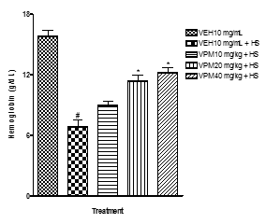

**Figure 1c: Effect of verapamil on haemoglobin content in mice subjected to hypoxic stress**

# represents significance (p<0.05) in relation to the non-stress control group.

* represents significant difference (p<0.05) in relation to the stress-control group.

**VEH –** Vehicle**. VPM –** Verapamil. **HS –** Hypoxic Stress

**Changes in blood volume parameters in mice subjected to hypoxia**

As presented in Table 1 below, hypoxic stress had a negative effect on blood volume with significant reductions in all measured parameters. However, these effects were significantly reversed by verapamil at much higher doses.



Each result is expressed as mean ± S.E.M of grouped mice (n=3).

# represents significance (p<0.05) in relation to the non-stress control group.

* represents significant difference (p<0.05) in relation to the stress-control group.

**VEH –** Vehicle**. VPM –** Verapamil. **HS –** Hypoxic Stress

**Prooxidant levels in lungs of mice exposed to hypoxia**

Hypoxic stress caused significant increment in prooxidant levels. MDA (Figure 2a), MPO (Figure 2b) and nitrites (Figure 2c) were significantly increased in the stressed group when compared to the non-stressed group. On the other hand, verapamil pre-treatment resulted in a significant depletion of these prooxidants.



**Figure 2a: Effect of verapamil on lung malondialdehyde level in mice subjected to hypoxic stress**

# represents significance (p<0.05) in relation to the non-stress control group.

* represents significant difference (p<0.05) in relation to the stress-control group.

**VEH –** Vehicle**. VPM –** Verapamil. **HS –** Hypoxic Stress

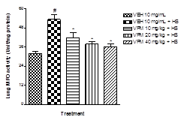

**Figure 2b: Effect of verapamil on lung myeloperoxidase activity in mice subjected to hypoxic stress**

# represents significance (p<0.05) in relation to the non-stress control group.

* represents significant difference (p<0.05) in relation to the stress-control group.

**VEH –** Vehicle**. VPM –** Verapamil. **HS –** Hypoxic Stress

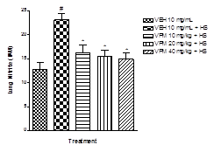

**Figure 2c: Effect of verapamil on lung nitrite level in mice subjected to hypoxic stress**

**# represents significance (p<0.05) in relation to the non-stress control group.**

**\* represents significant difference (p<0.05) in relation to the stress-control group.**

**VEH – Vehicle. VPM – Verapamil. HS – Hypoxic Stress**

**Antioxidant levels in lungs of mice exposed to hypoxia**

Hypoxic stress caused significant depletion in antioxidant molecules and a reduction in their activity. SOD (Figure 3a), CAT (Figure 3b), GSH (Figure 3c), and GPx (Figure 3d) were significantly diminished in the stressed group when compared to the non-stressed group. On the other hand, pre-treatment with verapamil resulted in a significant increase in antioxidant levels and activity.

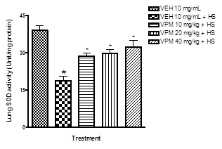

**Figure 3a: Effect of verapamil on lung superoxide activity in mice subjected to hypoxic stress**

# represents significance (p<0.05) in relation to the non-stress control group.

* represents significant difference (p<0.05) in relation to the stress-control group.

**VEH –** Vehicle**. VPM –** Verapamil. **HS –** Hypoxic Stress

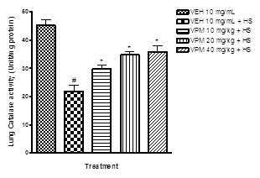

**Figure 3b: Effect of verapamil on lung catalase activity in mice subjected to hypoxic stress**

# represents significance (p<0.05) in relation to the non-stress control group.

* represents significant difference (p<0.05) in relation to the stress-control group.

**VEH –** Vehicle**. VPM –** Verapamil. **HS –** Hypoxic Stress

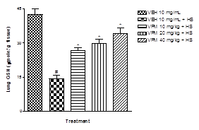

**Figure 3c: Effect of verapamil on lung glutathione level in mice subjected to hypoxic stress**

# represents significance (p<0.05) in relation to the non-stress control group.

* represents significant difference (p<0.05) in relation to the stress-control group.

**VEH –** Vehicle**. VPM –** Verapamil. **HS –** Hypoxic Stress

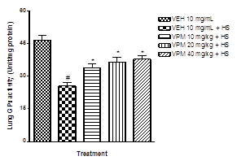

**Figure 3d: Effect of verapamil on lung glutathione peroxidase activity in mice subjected to hypoxic stress**

# represents significance (p<0.05) in relation to the non-stress control group.

* represents significant difference (p<0.05) in relation to the stress-control group.

**VEH –** Vehicle**. VPM –** Verapamil. **HS –** Hypoxic Stress

**Effect of verapamil on the histoarchitecture of lung tissue of mice exposed to hypoxia**

The photomicrograph in Figure 4 shows the narrowing of capillaries (vasoconstriction) and fewer pneumocytes in the lung alveoli tissue of mice exposed to hypoxia i.e., stressed group (slide G) when compared to non-stressed mice (slide N). However, verapamil administration significantly (p<0.05) reversed these effects by increasing pneumocyte counts and enhancing vasodilatation (slides H-J).

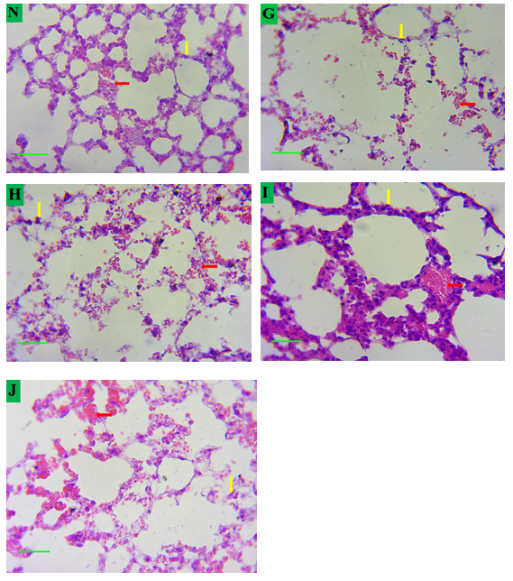

**Figure 4: Photomicrograph showing the effect of verapamil on the lung alveoli tissue in mice subjected to hypoxic stress**

**Key:**

**N–**VEH 10 mL/kg (non-stressed group)

**G** – VEH 10 mL/kg+HS (stressed group)

**H** – VPM 10 mg/kg+HS

**I**– VPM 20 mg/kg+HS

**J**– VPM 40 mg/kg+HS

**Red arrow**: Capillaries

**Yellow arrow**: Pneumocytes

**VEH –** Vehicle**. VPM –** Verapamil. **HS –**Hypoxic Stress

DISCUSSION

This study investigated the effects of verapamil on blood components, blood volume, lung oxidative parameters and lung histology in mice subjected to repeated intermittent hypoxia.

Hypoxia is a condition characterized by an inadequate supply of oxygen to the tissues of the body. If the oxygen entering inside a cell is not matching the oxygen demand of the same cell, a hypoxic condition is created. In a cell, this imbalance can arise due to physiological or pathophysiological processes such as during inflammation, gestation/fetal development, wound healing, adapting to a high altitude, etc.15

Inside the lungs, oxygen is exchanged for carbon dioxide waste through the process called external respiration. During the respiratory process, oxygen from environmental air diffuses into the surrounding pulmonary capillaries which then binds to haemoglobin molecules residual in red blood cells and is pumped into the blood stream. Meanwhile, carbon dioxide from deoxygenated blood diffuses from the capillaries into the alveoli and is expelled through exhalation. This means that the lungs are responsible for oxygenation of blood cells and removal of waste gases from the cells. Consistent with this very important function of the lungs in proper body functioning, diseases that affect the lungs are therefore considered as life-threatening. Some of these diseases include asthma, emphysema, bronchitis, chronic obstructive pulmonary disease (COPD), etc.

Results from this study show that the unavailability of adequate oxygen available to the lungs resulted in an increase in prooxidant levels as measured by MDA and NO, with a concurrent decrease in antioxidant levels and activity as measured by SOD, CAT, GSH, and GPx. This agrees with results from previous researches which had pointed out that some of these inflammatory lung diseases are linked to oxidative stress.16-19 Oxidants may play a role in increasing inflammation via the activation of various kinases and transcription factors such as NF-kappa B and AP-1.18,20 Furthermore, hypoxia and inflammation are intertwined at the molecular, cellular, and even clinical levels.21-23 This hypoxia-induced inflammatory response results in the recruitment of immune cells, the activation of downstream signaling pathways, and the induction of pro inflammatory cytokines and chemokines.21 Also from the current research, MPO levels were higher in mice

exposed to chronic hypoxia as opposed to those that were not. This is an indication of the onset of inflammation. This correlates with an older study that found an association between hypoxia and increased inflammatory responses in the lungs.24

The histological evaluation of the lungs in the current research shows the narrowing of capillaries (vasoconstriction) and fewer pneumocytes in the lung alveoli tissue of mice subjected to hypoxia. This is in agreement with existing literature which states that an acute onset of hypoxia leads to vasoconstriction (also known as hypoxic pulmonary vasoconstriction), which is very different from the usual vasodilatation caused by hypoxia in all other organs.25

Also from the current research, the hematological assay revealed a hypoxia-induced generalized decrease in majority of the blood parameters measured with only the exception of the white blood cell count. Hypoxia caused a significant decrease in the red blood cell count, hemoglobin content, PCV, MCV and MCHC. This agrees with existing literature which posited that anemic hypoxia drastically reduces the oxygen –carrying capacity of red blood cells which may even affect erythropoiesis.26 However, the increase in white blood cell (leucocyte) count is similar to the increase in MPO activity observed in the lungs; both signify an inflammatory response to hypoxia.

On the other hand, mice which treated with varying dose levels of verapamil after exposure to hypoxia demonstrated a significant attenuation of the negative impact of hypoxia on mice lungs and blood. An increase in intracellular calcium levels, which usually results in the activation of calcium-dependent protein kinases, has been implicated as a cellular

response to hypoxia.27 This increase in calcium influx has also been shown to play a role in inflammation which most likely precedes the incidence of diseases via the generation of oxidative stress. Supporting, there is evidence that shows that calcium channel blockers inhibit hypoxic pulmonary vasoconstriction in experimental animals.28,29

**Conclusion**

From the foregoing evidence, a calcium antagonist such as verapamil possesses the ability to abrogate the diverse deleterious effects of hypoxia on lung tissues and blood of nice. However, more research in this direction is needed to estimate the extent of benefit of verapamil in hypoxia.

## REFERENCES

1. Behn, C., Araneda, O. F., Llanos, A. J., Celedon, G., Gonzalez, G. (2007). Hypoxia-related lipid peroxidation: evidences, implications and approaches. Respiratory Physiology and Neurobiology **158**: 143-150
2. Araneda, O., Garcıa, C., Lagos, N., Quiroga, G., Cajigal, J., Salazar, M.P., Behn, C. (2005). Lung oxidative stress as related to exercise and altitude. Lipid peroxidation evidence in exhaled breath condensate: a possible predictor of acute mountain sickness. Eur. J. Appl. Physiol. **95:** 383–390
3. Semenza, G. L. (2007). Life with oxygen. Science **318**: 62–64.
4. Caillard, C., Menu, M., Rassignol, P. (1975). Do anti-convulsant drugs exert protective effect against hypoxia? Life Sci. **16**: 1607–1611
5. Aluko, O. M., Umukoro, S., Annafi, O. S., Adewole, F. A., Omorogbe, O. (2015). Effects of methyl jasmonate on acute stress responses in mice subjected to forced swim and anoxic tests. Scientia Pharmaceutica **83** (4): 635-644.
6. Ajonijebu, D. C., Olayanju, A. O., Eduviere, A. T., Adewumi, F. A., Atodo, K. U., Akinsanya, B. T., et al. (2016). Effects of Calcitriol Supplementation on the Hematological Parameters of Sleep Deprived Wistar Rats. International Journal of Health Sciences & Research, **6** (3): 127-134.
7. Moron, M. S., Depierre, J. W., Mannervik, B. (1979). Levels of glutathione, glutathione reductase and glutathione S-trans­ferase activities in rat lung and liver. Biochimica et Biophysica Acta (BBA) - General Subjects **582** (1): 67–78.
8. Okhawa, H., Ohishi, N., Yagi, K. (1979). Assay for lipid peroxides in animal tissues by thiobarbituric acid reaction. Anal. Biochem. **1995**: 351–358.
9. Umukoro, S., Aluko, O. M., Eduviere, A. T., Owoeye, O. (2016). Evaluation of adaptogenic-like property of methyl jasmonate in mice exposed to unpredictable chronic mild stress. Brain Res Bull.**121**:105-114.
10. Goth, L. A. (1990). Simple method for determination of serum catalase activity and revision of reference range. Clin. Chim. Acta **196**: 143–151.
11. Green, L. C., Tannenbaum, S. R., Goldman, P. (1981). Nitrate synthesis in the germ free and conventional rat. Science **212:** 56–58.
12. Eduviere, A. T., Umukoro, S., Adeoluwa, O. A., Omogbiya, A. I., Aluko, O. M. (2016). Possible mechanisms involved in attenuation of lipopolysaccharide-induced memory deficits by methyl jasmonate in mice. Neurochemical Research **41** (12): 3239-3249
13. Pulli, B., Ali, M., Forghani, R., Schob, S., Hsieh, K. L. C., Wojtkiewicz, G., Linnoila, J. L., Chen, J. W. (2013). Measuring myeloperoxidase activity in biological samples. PLoS One **8** (7): e67976
14. Emokpae, O., Ben-Azu, B., Ajayi, A. M., Umukoro, S. (2020). D-Ribose-L-cysteine attenuates lipopolysaccharide-induced memory deficits through inhibition of oxidative stress, release of pro inflammatory cytokines, and nuclear factor-kappa B expression in mice. Naunyn-Schmied. Arch. Pharm. **393:** 909–925.
15. Sridharan, S., Varghese, R., Venkatraj, V., Datta, A. (2016). Hypoxia stress response pathways: modeling and targeted therapy. IEEE Journal of Biomedical and Health Informatics **2016**: 2168-2194
16. Caramori, G., Papi, A. (2004). Oxidants and asthma. Thorax **59** (2): 170-173
17. Guo, R. F., Ward, P. A. (2007). Role of oxidants in lung injury during sepsis. Antioxid. Redox. Signal. **9** (11): 1991-2002
18. Hoshino, Y., Mishima, M. (2008). Antioxidants & redox signalling redox-based therapeutics for lung diseases. Antioxid. Redox. Signal. **10**: 701-704

MacNee, W., Rahman, I. (2001). Is oxidative stress central to the pathogenesis of chronic obstructive pulmonary disease? Trends in molecular medicine **7** (2): 55-62

1. MacNee, W., Rahman, I. (2001). Is oxidative stress central to the pathogenesis of chronic obstructive

pulmonary disease? Trends in molecular medicine **7** (2): 55-62

1. MacNee, W. (2001). Oxidative stress and lung inflammation in airways disease. European Journal of Pharmacology **429** (1-3): 195-207
2. Eltzschig, H. K., Carmeliet, P. (2011). Hypoxia and inflammation. N Engl J Med **364**: 656–665.
3. Schumacker, P. T. (2011). Role of Mitochondrial Reactive Oxygen Species Signaling in Triggering Responses. Proc Am Thorac Soc **8**: 477–484.
4. Park, H. S., Kim, S. R., Lee, Y. C. (2009). Impact of oxidative stress on lung diseases. Respirology **14:** 27–38
5. Frohlich, S., Boylan, J., McLoughlin, P. (2013). Hypoxia-Induced Inflammation in the Lung. Am J Respir Cell Mol Biol **48** (3): 271–279
6. Sylvester, J. T., Shimoda, L. A., Aaronson, P. I., Ward, J. P. T. (2012). Hypoxic pulmonary vasoconstriction. Physiological reviews **92** (1): 367-520
7. Pittman, R. N. Regulation of Tissue Oxygenation. San Rafael (CA): Morgan & Claypool Life Sciences; 2011. Chapter 7, Oxygen Transport in Normal and Pathological Situations: Defects and Compensations
8. Seta, K. A., Yuan, Y., Spicer, Z., Lu, G., Bedard, J., Ferguson, T. K., et al. (2004). The role of calcium in hypoxia-induced signal transduction and gene expression. Cell Calcium **36** (2004): 331-340
9. Tucker, A., McMurtry, I. F., Grover, R. F., et al. (1976). Attenuation of hypoxic pulmonary vasoconstriction by verapamil in intact dogs. Proc Sot Roy Biol Med **151**: 611-614.
10. Kennedy, T. P., Michael, J. R., Summer, W. (1985). Calcium channel blockers in hypoxic pulmonary hypertension. The American Journal of Medicine 78 (2B): 18-26

## ACKNOWLEDGEMENTS

## Special thanks to the co-authors for their invaluable contributions