BREAST HEMANGIOMA: A RARE TUMOUR PRESENTING AS A PALPABLE BREAST MASS IN A MALE CHILD

Adegboyega OA^{1*}, Abdulsalam M², Osuoj RI², Emiogun EF³, Ojo OT⁴

¹Department of Radiology, Lagos State University Teaching Hospital Ikeja, Nigeria
²Department of Surgery, Lagos State University Teaching Hospital Ikeja, Nigeria
³Department of Forensic Pathology, Lagos State University Teaching Hospital Ikeja, Nigeria
⁴Department of Medicine, Lagos State University Teaching Hospital Ikeja, Nigeria
*Corresponding Author: dadegboyega@yahoo.com, +2348023050671.

ABSTRACT

Background: Hemangioma of the breast is a rare benign variety of vascular tumours. They are usually small and most patients are asymptomatic. It is either diagnosed accidentally for different purposes (red herring) or at autopsies. Globally, there are scanty publications in the literature about this rare entity since the first publication in 1936.

Case: Our report focuses on the exceptional occurrence of this case, specifically in a male child who was just 9 years of age which is below the minimum age of occurrence in this gender reported in the literature. Ultrasound examination with Doppler interrogation reveals vague reports with a suspicion of malignancy. Mammography could not be performed because the dense mass would be obscured by the normal soft tissue density of the breast for the patient’s age. An extensive and complete surgical excision was performed due to the equivocal ultrasound findings. The insidious growth in tumour size and inclusive findings on aspiration cytology required open surgery with histology.

Conclusion: We present a case of the largest known breast benign hemangioma in a 9-year-old boy with equivocal ultrasound findings. The value of imaging in identifying the differential diagnosis of hemangioma cannot be overemphasised. However, the mainstay of diagnosis remains a histological biopsy, which revealed a benign breast hemangioma.

Keywords: hemangioma, breast cancer, rare vascular tumour, male breast

INTRODUCTION

Vascular tumours of the breast are extremely rare and can pose a diagnostic dilemma. ^{1,2}
It accounts for only 0.4% of all breast tumours. ³ Benign variants of these vascular tumours of the breast are even rarer when they occur in men compared to women^{. 4} The appearance of this benign tumour in men is usually between the ages of 30 and 82 years. ⁴ The International Society for the Study of Vascular Anomalies (ISSVA) classifies it into; Congenital hemangioma, containing spindle cells, epithelioid hemangioma, and intramuscular hemangioma. ⁵ In assessing a breast mass, the duration, associated pain, or other symptoms, the growth rate, and the presence of a family member with similar breast disease. ^{6, 7} are all important factors to be considered.
Breast hemangiomas are usually small and patients are often asymptomatic with lesions discovered during various biopsies and postmortem studies ^{3,8} These lesions infrequently present as clinically palpable tumours. ^{9,10}
Since its first publication in 1936 ¹¹ , some case reports have been described. However, there is a shortage of publications in literature in this age and gender. A cautious approach should be taken as most breast tumours in young people are non-cancerous. Customized diagnosis and treatment are essential to prevent harm to developing breast tissue, which could lead to underdevelopment or absence (hypoplasia or aplasia). ^{6, 7}
However, complete surgical excision remains the treatment of choice for this entity when imaging features are either not classical or even a pose diagnostic dilemma. ^{12, 13}
We present a very uncommon case of the largest benign hemangioma of the breast in a 9-year-old male child never reported this age for males with some atypical imaging and clinical features that had evidence of invasion of affected pectoralis muscle and nipple destruction simulating malignancy; with equivocal ultrasound with Doppler findings.

Figure 1A: shows a left breast swelling or mass with associated nipple swelling and displacement superolaterally

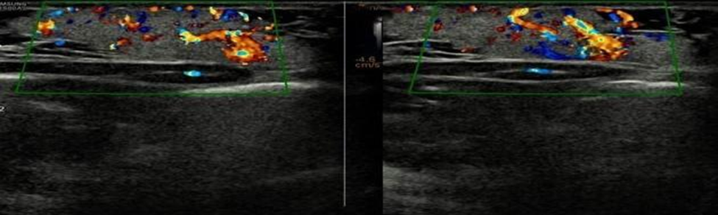
Figure 2: Colour flow Doppler ultrasound scan shows predominantly hypervascular vessels with flow toward the heart in the area overlying the large lobulated breast parenchymal mass. Histology confirmed soft tissue haemangioma.
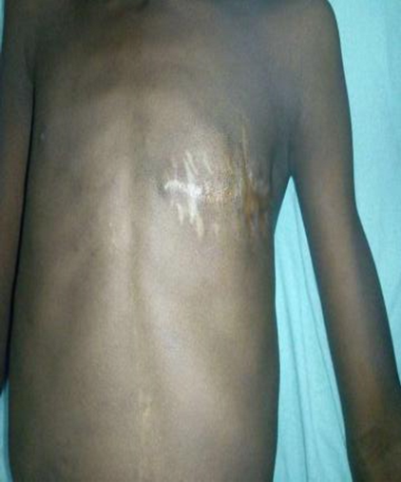
Figure 3: demonstrates the left breast scar of the same patient after a wide excisional biopsy.

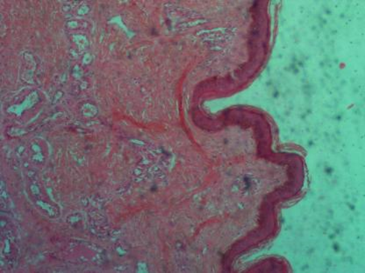
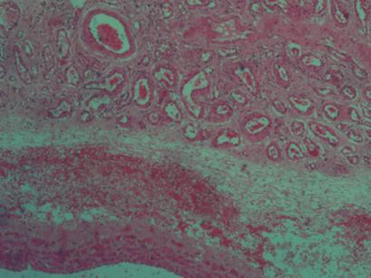
Figure 4: Histologic sections show skin tissue. Within the dermis are proliferating vascular channels arranged in lobules, surrounded by oedematous stroma with moderate inflammatory infiltrates and haemorrhage. These vessels are lined by regular flattened endothelial cells. Other areas show larger dilated vascular vessels

CASE PRESENTATION
A 9-year-old boy was brought to the pediatric surgical clinic following a presentation of a painless left breast lump which was first noticed at birth. Initially, it was the size of half an adult’s thumb (4 cm) but progressively increased to the size of about half a lawn tennis ball (8 cm). No associated nipple discharge.
Approximately 2 months before presentation at the hospital, groundnut-sized swellings (2 cm) developed over the initial lesion with spontaneous bleeding episodes originating from this second lesion which simulates a lobulated mass. ⁷
There was no swelling in the right breast or other body parts. No history of trauma, chronic cough, fever, excessive night sweats, family history of male breast development or breast cancer.
The patient is not receiving hormone therapy. There has been no weight loss, chest pain, breathing difficulty, jaundice, abdominal pain, or bone pain. He has not had any hospitalizations, blood transfusions, or surgeries. Physical examination revealed a hard, non-tender, well-circumscribed mass in the left breast. It measures 8cm x 2 cm. A 2 cm rectangular hyperpigmented swelling was seen overlying the primary lesion, displacing the nipple laterally. The upper and surrounding skin was normal (Figure 1A). No distortion in the nipple-areola complex. No palpable axillary or supraclavicular lymph nodes were seen. The breast on the right side was normal, groundnut-sized swellings. Breast ultrasound with Doppler showed a lobulated heterogeneous mass with hypervascularity occupying the entire left chest quadrant (Figure 2). There was a mass seen obliterating the retromammary space and penetrating the pectoral muscle, with the destruction of the nipple. An excisional biopsy was performed with intraoperative findings of a left breast mass that measured about 8 cm in diameter, with a 2cm by 1cm nodular lesion on top of it. The breast mass was well vascularised. There was excellent healing with the post-surgical excision scar (Figure 3).

DISCUSSION
Hemangiomas are tumours of the blood vessels that can be either non-cancerous (benign) or cancerous (malignant) and can occur in different organ systems such as the brain, liver, skin, and breast. Non-cancerous vascular growths occurring in the breast were reviewed and described by Jozefczyk et al. ¹⁴ Commonly seen in females but exceptionally rare in males. ¹⁴ In 1936, the inaugural instance of hemangioma in the male breast was documented by Dr. Johnston in "Cancer Research" at the University of Maryland. ¹¹
Breast Hemangiomas are more common in women ^{2,15} with an age range of 18 months to 82 years. ¹⁶ Men are barely affected ⁹ and when affected, the age range is 30-84 years. ⁴
The frequency of occurrences in male breast haemangioma is unknown and presently only about 16 previous cases have been documented in the literature according to Alwani et al. ²⁰
Our case report of breast haemangioma was seen in a male child of 9 years which is quite rare in the literature. This to our knowledge is the first known published case of male hemangioma in a 9-year-old child who is quite below the 30 years old minimum age range of occurrence in the literature.

The pathogenesis of haemangioma is still not understood. Although it has been postulated that hormones and growth factors as well as mechanical influences may induce abnormal proliferation of endothelial cells in haemangioma, however, the primary cause of the defect is still very much a mystery and no genetic defect has been associated with the condition. ¹⁷
Hemangioma can be seen in various body parts, but only a few have been recorded in the breast area. ^{14, 18, 19}
Although benign breast hemangiomas are usually found incidentally through imaging modalities, including mammography, ultrasonography (US), or magnetic resonance imaging (MRI), they often pose diagnostic dilemmas with equivocal findings. ¹⁴
Breast ultrasound, with emphasis on technique, gives a more precise location of a palpable lesion about the breast skin, subcutaneous tissue, and parenchyma.
Breast hemangioma exhibits a variable appearance on ultrasonography, typically manifesting as an oval mass located superficially with parallel orientation and well-defined margins. The internal echo structure varies, and the tumour may present as hypoechoic, isoechoic, or hyperechoic. ^{1, 6,7, 15, 20,21} Detecting the compressibility of the tumour is feasible only in the absence of thrombosis. ¹¹ In certain instances, an isoechoic tumour may not be distinguishable from the surrounding adipose tissue. ⁹ Despite the lack of reported diagnostic value in tumour vascularity ^{2, 22}, the presence of hyper-vascularity may indicate suspicion of malignancy. ¹¹ Our case had a suspicion of malignancy due to the destruction of the pectoralis muscle and nipple along with doppler findings of hyper-vascularity. (Figure 2).
Although the cytology finding was also inconclusive which necessitated surgical excision, the histology report confirmed a benign breast hemangioma. The histology showed proliferating vascular channels arranged in lobules, surrounded by oedematous stroma with moderate inflammatory infiltrates and haemorrhage within the dermis. These vessels are lined by regular flattened endothelial cells. Other areas show larger dilated vascular vessels (Figure 4). This further attests to the fact that imaging findings might be misleading but histology would give a better definitive diagnosis or confirmation. ^{2, 22}
It is very uncommon for a benign vascular tumour-like hemangioma to have such aggressive behaviour. Angiosarcomas, a close differential diagnosis, are known to exhibit such aggressive tendencies. There are no pathognomonic features for breast hemangiomas ^{8,9} causing imaging modalities to give misleading diagnoses in some cases. ^{9, 23} Furthermore, benign vascular hemangiomas cannot be accurately differentiated from angiosarcoma with imaging without correlation with histology. ^{2,8} This was corroborated by the case under review. This is quite important as both lesions have different surgical management.
In mammography, a breast hemangioma might be observed as a clearly outlined, well-defined, lobulated mass with a density similar to the surrounding breast tissue. ¹⁸
These lesions are small making them difficult to assess in cranio-caudal or medio-lateral oblique views with the tangential view as a better form of evaluation. ⁸ However, there may be limitations to the use of mammography in patients with dense breast tissue, particularly young adults below 40 years of age. ² The soft tissue lump infrequently contains micro-calcifications ^{1, 3, 9, 10,22} of fine, punctuate, or phlebolith patterns. ⁵ The evidence of micro-calcifications on both mammograms and ultrasonography are findings that are suspicious of a malignant process. ¹¹ Our case was found in a child and mammography was not considered valuable for further diagnosis in this age group.
In pediatric patients, MRI of the breast is rarely used, though in select cases, it may be useful for surgical planning or assessing the extent of disease. ⁶
The fact that MRI is rarely used for imaging soft tissue of the breast may account for why, there is a dearth of reports about MRI features of breast hemangioma ^{6, 10, 21}, it is well known that MRI could detect inconspicuous lesions because of its excellent soft tissue resolution. ²⁴ Breast hemangioma appears as an ovoid mass that is isointense and hyper-intense to surrounding fibro-glandular tissue on T1-weighted images and on T2-weighted images respectively. ³ There may be hypointense areas in the primary lesion due to calcifications, phlebolith, and fibrous tissue seen in T1 and T2 weighted images. ¹
Nonetheless, the MRI results exhibit variability contingent on factors such as size, the specific type of hemangioma ¹⁶, and the potential presence of internal thrombosis. Pre-surgical diagnosis of breast hemangioma is cumbersome. ^{1, 9, 13}
Surgery varies from wide local excision to mastectomy, especially where haemangiosarcoma is suspected. Nonetheless in special cases where the radiological features are classical and an imaging-guided biopsy is exact enough to exclude a malignant process, surgery may be avoided. ¹⁴ In cases where bleeding or ulceration has occurred, this will require local wound care before local excision. Daily use of a pressure garment for at least 22 hours has been recommended as an adjunct to definitive treatment, especially in adolescents where local excision may cause injury to the developing breast bud. ²⁵

Conclusion: Our index case had a wide local excision with a histological diagnosis of breast hemangioma contrary to the USS finding of invasion of the pectoralis muscle and destruction of the nipple and non-specific doppler findings of hypervascularity. Summarily, breast hemangioma is an infrequent benign vascular tumour devoid of pathognomonic imaging characteristics. However, in cases with classical imaging findings and a confirmed diagnosis of breast hemangioma from image-guided core biopsy, conservative management with follow-up imaging seems non-detrimental., whereas in atypical cases with ambiguous radiological and pathological findings, a complete surgical resection of the vascular lesion is imperative to rule out the possibility of an underlying angiosarcoma or malignant process.

REFERENCES
- Jesinger RA, Lattin Jr. GE, Ballard EA, Zelasko SM, Glassman LM. Container Breast Abnormalities: Arterial and Venous Diseases, Vascular Masses, and Facial Expressions There were lesions with radiological and pathological correlations. Radiographics. 2011, 31(7):117-36. https://doi.org/10.1148/rg.317115503
- Funami N, Tabei I, Sekine C, Fukuie A, Yabe M, Takeyama H, Okamoto T. Brust Hemangioma difficult to diagnose preoperatively: a case report. World journal Surgical Oncology. 2014; 12(1):1-4. https://www.ncbi.nlm.nih.gov/pmc/articles/PMC4200173/
- Kim JH, Jung H, Cho YU. Giant mixed hemangioma of the breast: A case report with imaging findings. Radiology Case Reports. 2023;18(5):1710 https://www.ncbi.nlm.nih.gov/pmc/articles/PMC9989314/
- Mojtahedi FF, Bulut T, Oosterhof-Berktas R, Bezooijen R. 5 Hemangiomas in men's Chest. Medical Incident Journal. 2016; 7(8):323-5. https://www.journalmc.org/index.php/JMC/article/view/2578/1915
- Classification | International Society for the Study of Vascular Anomalies [Internet]. Issva.org. 2023 [cited May 25, 2023]. Available at: https://www.issva.org/classification
- Kaneda HJ, Mack J, Kasales CJ, Schetter. Breasts masses in Children and Adolescents: A review of pathophysiology, imaging, diagnosis, and treatment. AJR 2013; 200(2):204-12. https://pubmed.ncbi.nlm.nih.gov/23345385/
- Garcia CJ, Espinoza A, Dinamarca, Navarro O, Daneman A, Garcia H, et al. Breast US in children and adolescents Radiographics 2000; 20(6):1605–1612 https://pubmed.ncbi.nlm.nih.gov/11112814/
- Tilbe A, Maro R, Perez A, Santiago P. Breast hemangioma: correlation between imaging and pathological findings. Journal of Clinical Ultrasound. 2012; 40(8):512-7. https://pubmed.ncbi.nlm.nih.gov/22434703/
- Conde DM, de Paula ÉC, Jares RM, de Paula HM, de Souza JA. clinical Palpable cavernous hemangioma in the breast of an 80-year-old woman. European magazine in Obstetrics, Gynecology, and Reproductive Biology. 2013; 167(2):236-7. https://pubmed.ncbi.nlm.nih.gov/23280280/
- Kim SJ, Han HS, Kim JS, Park JH, Chung HJ, Lee JG. Cavernous hemangioma Breast parenchyma with abnormal features. Journal of Ultrasound in Medicine. 2006; 25(10):1343-6. https://pubmed.ncbi.nlm.nih.gov/16998110/
- Yoga A, Lyapichev KA, Bek D, Gomez-Fernandez CR. 2 Hemangiomas in men Breast: Case report and literature review. American Journal of Case Reports. 2018;19:1425. https://www.ncbi.nlm.nih.gov/pmc/articles/PMC6287655/
- Jghaimi F, Baallal H, Fakhri A, Rais H, Karbout N, Akhdari N, Amal S, Belaabidia B. Curious vascular tumour. Case Reports in Dermatological Medicine. 2012 ;2012.https://pubmed.ncbi.nlm.nih.gov/23227370/
- Frey JD, Levine PG, Darvisian F, Shapiro RL. 1 Angiosarcoma of the breast masquerading as a hemangioma: exploring clinical and pathological diagnostic challenges. Plastic Surgery Archives. 2015; 42(02):261-3. https://www.ncbi.nlm.nih.gov/pmc/articles/PMC4366719/
- Jozefczyk MA, Rosen PP. Breast vascular tumours. 2 II. Perilobular Hemangioma and hemangioma. American Journal of Surgical Pathology. 1985; 9(7):491-503. https://pubmed.ncbi.nlm.nih.gov/4091183/
- Kondi-Pafiti A, Dellaportas D, Myoteri D, Tsagkas A, Ntakomyti E, Kairi-Vasilatou E. Rare non-epithelial primary breast neoplasms: 10 years of experience at a Greek university. Hospital. J. Buon. 2013; 18(1):70-6 https://pubmed.ncbi.nlm.nih.gov/23613391/
- Mesurolle B, Sygal V, Lalonde L, Lisbona A, Dufresne MP, Gagnon JH, Kao E. Ultrasonographic and mammographic appearance of breast hemangiomas. American journal Radiology. 2008; 191(1):17-22. https://pubmed.ncbi.nlm.nih.gov/18562711/#:~:text=Conclusion%3A%20A%20mac%20 displaying%20an,the%20 possible%20 diagnosis%20of%20 hemangioma.
- Marchuk DA. Pathogenesis of hemangioma. Clinical Research Journal. 2001 ;(6):665-6. https://www.jci.org/articles/view/12470
- Rosen PP.vascular tumours of the breast: V. Nonparenchymal hemangioma of mammary subcutaneous tissues. American Journal of Surgical Pathology. 1985; 9(10):723-9. https://pubmed.ncbi.nlm.nih.gov/4061730/
- Salemis NS. Breast sinusoidal hemangioma: diagnosis evaluation management and literature review. Gland surgery. 2017; 6(1):105-9. https://gs.amegroups.org/article/view/13177/html
- Alwani AI, Schwartz MR, Riddle BC, Richard C, Ware LL. Haemangioma of the male breast: Presentation after a thorn injury.BJR/ Case Reports. 2021; 7(3)20200187. https://www.ncbi.nlm.nih.gov/pmc/articles/PMC8171138/
- Lee SH, Cho N, Kim SJ, Cha JH, Cho KS, Ko ES, Moon WK. correlation between high-resolution dynamic MR features and prognostic factors of breast cancer. Korean Journal of Radiology. 2008; 9(1):10-8. https://www.ncbi.nlm.nih.gov/pmc/articles/PMC2627175/
- Bonifazi E, Mileti F. Congenital hemangioma. 25 New England Medical Journal. 1999; 340(14):1080 https://www.nejm.org/doi/full/10.1056/NEJM199904083401405
- Siebert B, Jacobs T, Baum JK. Ultrasonographic evaluation of subcutaneous hemangioma on the chest. 2 American Journal of Roentgenology. 2002; 178(4):1025-7. https://pubmed.ncbi.nlm.nih.gov/11906894/
- Ameen R, Mandaria U, Mar AA, MacKenzie P. Breast hemangioma: MR appearance has histopathological correlation. Journal of Clinical Imaging Sciences. 2012; 2:53.4 https://www.ncbi.nlm.nih.gov/pmc/articles/PMC3440933/
- Atiyeh BS, El Khatib AM, Dibo SA. Pressure garment therapy (PGT) of burn scars: evidence-based efficacy. Annals of burns and fire disasters. 2013;26(4):205.https://www.ncbi.nlm.nih.gov/pmc/articles/PMC3978593/

